Thank you
We’d like to say thank you to Rev. Michael Turner, for allowing us to hold our Nativity in St John’s Church.
A big thank you goes out to parents for helping the children rehearse lines and make costumes.
Thank you also to PSA’s (Mrs Hodgkinson, Mrs Milne and Mrs Molland) for helping with costumes and learning lines.
And finally, a huge thank you and well done to the children, for all their hard work, dedication and commitment when rehearsing their show.

Collection
A collection will be held at the end of the service in aid of Aberlour Children’s Charity.

Community Café
Please join us back at Glenbervie Primary School at the end of the service for a hot drink, fine piece and craft fayre at our community café hosted by Primary 4/5.

Merry Christmas Everyone!
Sharing our Learning
Cross Curricular Learning
Primary 1, 2 and 3

Present:
Bethlehem Ballroom!

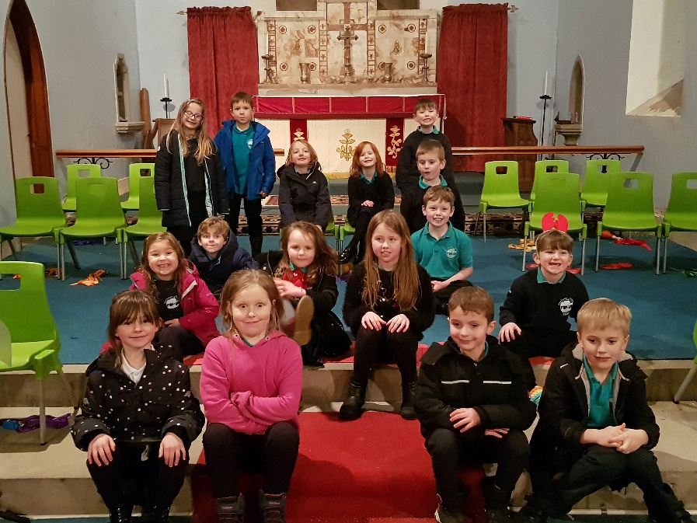

Dear Parents and Carers,
This term P 1, 2, and 3 have been working hard to put on a performance of the Nativity, ‘Bethlehem Ballroom’. Over the past few weeks, they have been working together to achieve their aims. This has involved developing a character, learning lines and lyrics, singing and playing songs from different styles, learning to project and speak with clarity and expression, and co-constructing movement and dance.
The classes have also had the opportunity to explore the Nativity story and discuss Christian celebrations and traditions that take place at Christmas time.
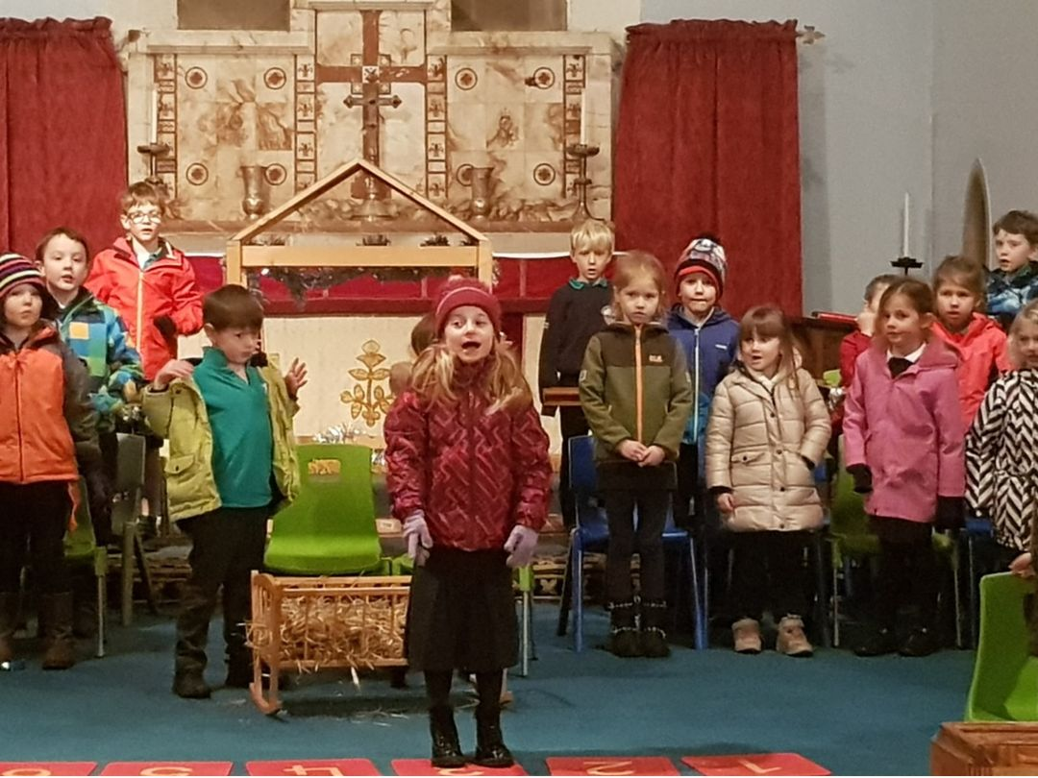

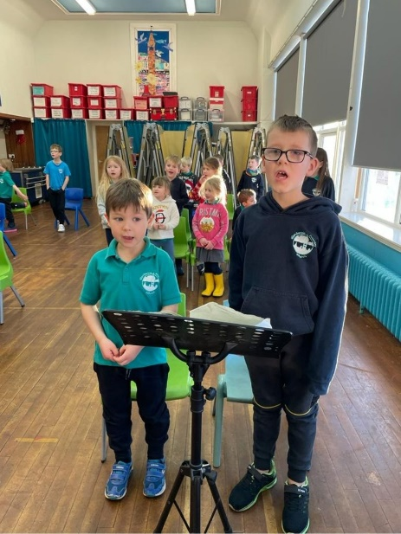
CfE Experience and outcomes covered…
I enjoy singing and playing along to music of different styles and cultures. EXA 0-16a/ EXA 1-16a
I enjoy creating, choosing and accepting roles, using movement, expression and voice. EXA 0-12a/ EXA 1-12a
I have developed confidence and skills in creating and presenting drama which explores real and imaginary situations, using improvisation and script. EXA 0-14a/ EXA 1-14a
I have opportunities to enjoy taking part in dance experiences. EXA 0-10a/ EXA 1-10a
Through exploring Bible stories, I can describe some beliefs Christians have about God and Jesus. RME 0-01a/ RME 1-01a
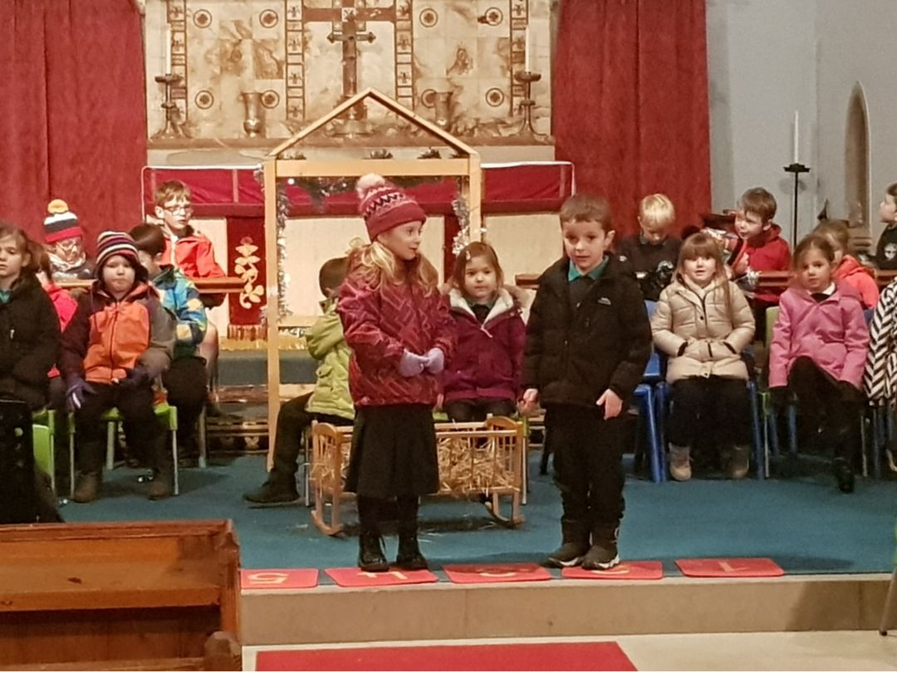
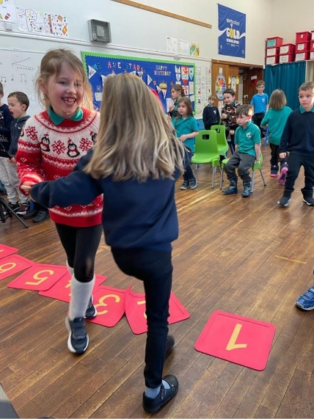
I am developing an awareness of the ways in which Christians celebrate different times of year and can relate these to my own life and community. RME 0-03a/ RME 1-03b

