Welcome to Primary 3/4 at Glenbervie School. We hope you all had a lovely summer break and are ready for the excitement and challenges of Primary 3/4!
We thought it would be helpful to share with you some of our routines, ways of working and what we have planned for the term ahead.

Seesaw
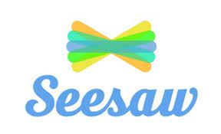
We will continue to use the Seesaw app as a way of reporting to parents about their child’s achievements and progress in class. Please try to check the app regularly for updates, including messages, reminders and homework.

Literacy
Spelling – Spelling has now begun in P3/4 (see Seesaw for more information on spelling routine). In spelling we will focus on word types and spelling rules. Please support your child at home by encouraging them to practice their spelling words and ensuring that all spelling homework tasks are completed.

Reading – Reading will also begin this week. Groups will read a variety of different types of text, for example, poetry, non-fiction, fiction and playscripts. Please check your child’s homework diary for any reading homework that has been set. It would also be helpful if you could encourage reading for enjoyment at home.

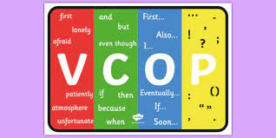
VCOP- The children will take part in various activities that help them to gain more knowledge about how to improve their own writing. As well as focusing on the genre specific writing features, they will be encouraged to always focus on four core targets – Vocabulary, Connectives, Openers and Punctuation (VCOP), as a way of improving all of their writing.

Numeracy and Maths
This term we will be looking at both multiplication and fractions. Having a good grasp of times table facts is an essential building block in many areas of maths, including fractions. Children will take part in various different activities to learn and reinforce these important life skills. Extra practice at home would also really benefit your child with their recall. This could be as simple as asking them times table questions during a car journey.

Topic
Our topic this term will be ‘The Human Body’. Through a variety of interdisciplinary activities we will be learning all about our senses, the major organs and how we can keep ourselves healthy.

Outdoor Learning
Forest School sessions will begin for P3/4 on Wednesday 14th September for a 4 week block. Reminders and information about what to take to school for these sessions will be posted on Seesaw.

Equipment
PE kit – PE kits will be required on a Thursday and please come to school dressed for outdoor PE on a Friday. A change of clothes/shoes might also be a good idea for after if needed.
Water bottles – the children should have a water bottle with them each day. This can be also be filled up at school.
Painting apron – A painting apron or an adults old t-shirt can be used to protect your child’s school uniform when doing messy activities. These can be kept in school.

Homework
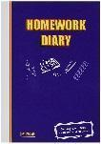
Please check your child’s homework diary on a daily basis for homework that has been assigned. You can also use these diaries for any non urgent messages you wish to pass on.

We look forward to working in partnership with you and would like to emphasise that if you have any questions/queries or concerns please do not hesitate to contact us.

Kind Regards,

Mrs Cerretti, Mrs McConachie and Mrs Russon

