P5/6 Newsletter TERM 1 2022
Welcome Back primary 5/6! We hope you all had a wonderful summer break and are well rested ready for another busy school year!
We are looking forward to spending this term getting to know your child, building a positive relationship, so that we can provide a learning environment that will motivate and engage them. We will be encouraging resilience and positive thinking. As a school we will be focussing on feedback and next steps.
We have reminded ourselves of our school values and expectations; Responsible, Respectful and Safe and will use these to support positive behaviours.
We are all settling in well to our new classes, finding our feet and learning our new routines. If you have any queries or concerns contact me through seesaw, or the home-school diary.
Day |  | Timetable of Important information
Mon |  | Spelling words uploaded to Seesaw.
Tue
Wed |  | PE day (wear to school)
Thurs |  | PE day (wear to school)  Bring violin (for those with music tuition)
Fri
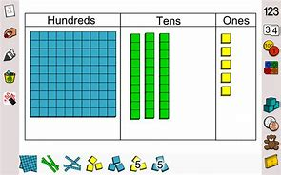
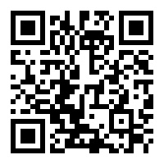
Maths
This term we will focus on place and value, addition and subtraction, Mental maths and Data handling. We will be learning timetables throughout the year and hope the children will continue to reinforce this at home through platforms such as Hit the button. Hit the button

Reading
Through reading groups we’ll progress our reading, including our new suite of Collins Big Cat reading scheme books. Home reading will be set by the teacher in your homework diary.

Topic - Space
Our class topic this term will be looking at Space. Within this topic we will be learning about the solar system and planets, magnetic and gravitational forces. We will also look at space travel and the technology involved. This will be achieved through a range of activities and develop a range of skills, such as, research, co-operation, problem solving and leadership.

Cross-Curricular
Throughout the year we will utilise the strengths of the staff; giving the children a wider range of skills and experiences. This term primary 5/6 will have a block of art and digital technology with Mrs McCormack.

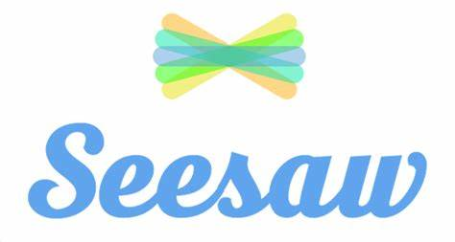
Opportunities to extend learning
A termly spelling grid will be provided in Seesaw. Please don’t “respond” to this in Seesaw, as it’s for reference only.
Weekly spelling words will be uploaded to Seesaw on a Monday. These are for learning throughout the week, and you can respond with a photo, video, or document.
Seesaw- New pupil and parent logins can be found in your homework diary.
GLOW- Logins have been written in diaries.
Any other logins and passwords will be noted in diaries, as needed.
Further opportunities to extend and consolidate learning through the term will also be added to Seesaw, linked to the in-class learning.

Please ensure you have a water bottle and diary with you daily. As we are out in all weathers please bring a jacket with you, as the weather can be unpredictable at times.

Best Wishes,
Mrs McCormack

