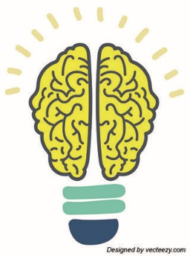
Visible Learning

What is Visible Learning?
Visible Learning is an approach to learning & teaching. It is based upon a large amount of evidence from New Zealand born researcher John Hattie. He was interested in the factors which impact positively upon teaching & learning and in turn, the factors which raise attainment. Here are some of the key ideas from the Visible Learning research:

- The whole school community should have a shared language of learning
- Learners should be at the centre of a Visible Learning approach surrounded by inspired & passionate teachers
- When learning is made ‘visible’ (teachers know what they are teaching and learners know what they are learning), achievement increases
- A visible learning approach supports pupils to become assessment capable learners who know where they are in their learning, where they are going next and how they are going to get there
- Effective feedback is crucial – it should be personal for each child and ‘just in time’
- The greatest effects on learning come when pupils are their own teachers and when teachers are learners

Parents’ Information Leaflet

Visible learning is all about children taking ownership for their learning.

Glenbervie Primary School
2020

How can I support my child at home?
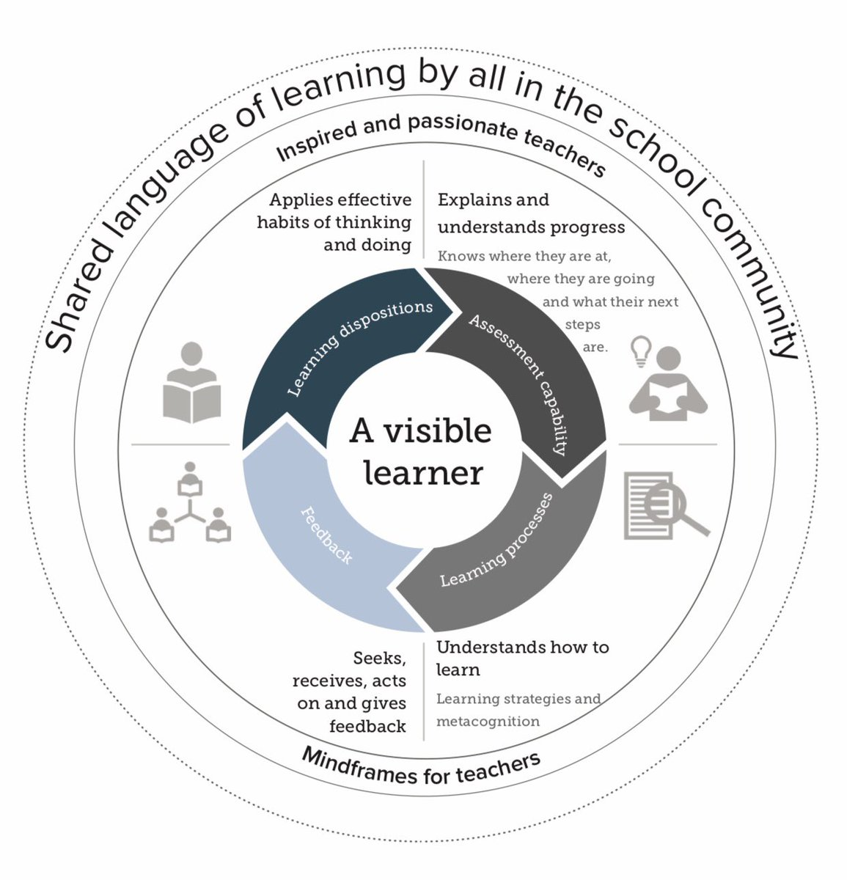
To support our work in school on developing a language of learning, we would encourage you to discuss learning at home too. Here are some ideas of questions you might like to use at home:

What was the best thing that happened at school today?

Tell me something that made you smile at school.

Tell me about something you learned or something you did.
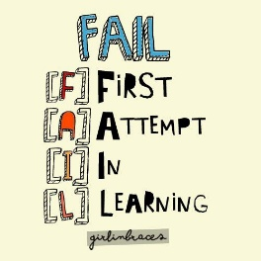
Was there anything you found tricky? What strategies did you use to help you in your learning?

Tell me one thing you learned at school today and I’ll tell you one thing I learned at work.

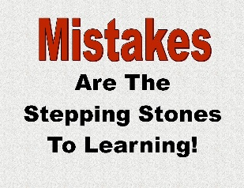
How were you challenged in your learning today?

What are you working on in Art /PE /Numeracy/reading/writing etc?
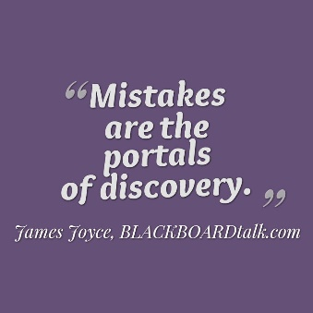
What are you looking forward to at school tomorrow?

Did you make any mistakes at school today? Tell me what you learned from them.
What challenged you most today?

What was the nicest thing you did for someone else today?
Do you have any questions that maybe your teacher could answer tomorrow?

What are your next steps on your learning journey in numeracy/science etc?

