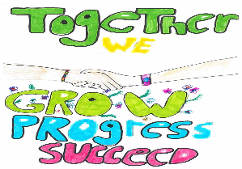

What is Seesaw?
Seesaw is a digital portfolio of your child’s work; it is a replacement for the red learning portfolios the children have had in the past. Seesaw provides a platform for sharing classroom experiences and achievements in real time with home and becomes a continuous record of their learning journey.
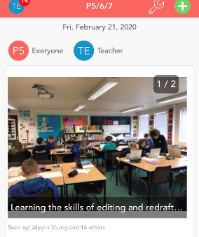
Each pupil has their own journal set up in their ‘Class’ and they are able to record their learning as it happens. They can take a photo of their work, they can record themselves talking about their learning, they can annotate items, or they can draw and explain as they go.
Seesaw allows us to share a range of files (jpg, png, mov, mp4, pdf,) that may be larger than our emails would allow. This will be of enormous benefit for assessments, feedback, support and send-in tasks.

What are the benefits?

Students | Families/ Home Tutors | Teachers
Encourages deeper learning and reflection.  Encourages peer feedback - students can share their work with other students and respond.  Opportunities for students to collaborate with teachers and other students.  Encourages responsibility and accountability.  Develops digital citizenship skills in a managed environment.  It’s engaging and gives the child ownership over their learning. | Instant notifications about your child’s school day and see feedback from teachers.  Accessible from any device, anytime, anywhere.  Saves on classroom resources.  Files can be uploaded that would be too large to email.  Can be shared with family members – not just parental access. You decide who you wish to connect to your child’s profile.  All data is safe and secure.  Communication tool with teachers. | Feedback is immediate and relevant.  Feedback can be given using a range of tools.  Activities can be assigned to individuals to ensure specific targets are being met, assessed and recorded.  Reporting to parents on progress throughout the school year, not just at parents’ evenings.  Provides evidence of learning and progressions.  Reduces the need for paper documents – reminders can be sent home through family announcements.  Communication tool with parents.

How do I access Seesaw?

Your child’s teacher will provide you with a QR code to allow you to connect with your child’s profile and follow their learning through the Seesaw classroom.
You can access seesaw using the QR code on a PC or by downloading the Seesaw app on your device. For more advice on how to connect follow the link below
https://help.seesaw.me/hc/en-us/articles/206514655-I-m-a-Family-member-How-do-I-add-my-child-s-journal-
You’ll be able to see posts in their journal, be notified about new posts and receive announcements from teachers. You will only be notified about your own child’s work (unless they have work collaboratively with others) and all data is safe and secure. Once connected you can comment on your child’s work and give feedback and you can connect privately with the teacher through messenger.

