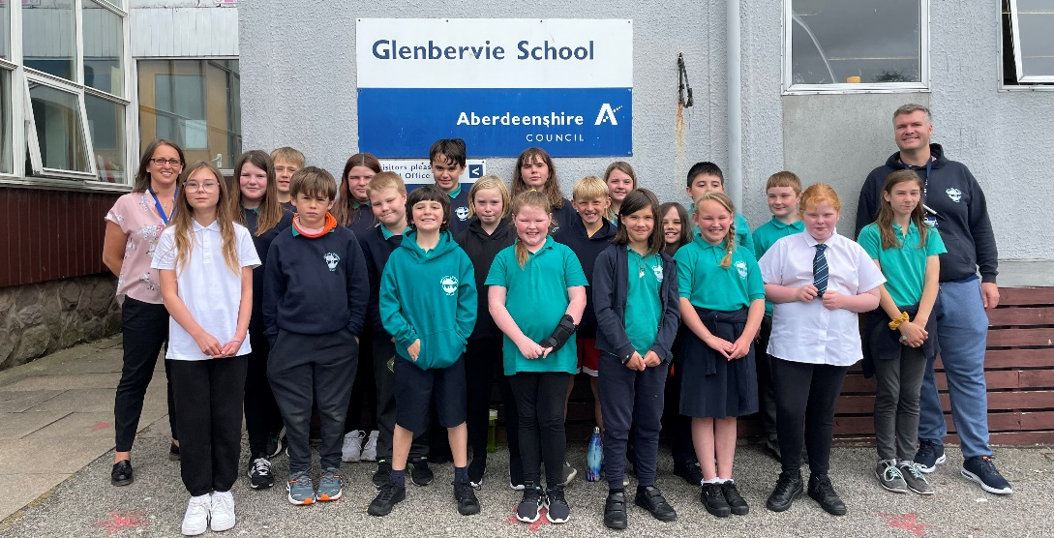

Welcome back to our 7s and a warm welcome to our primary 6 children who have joined us. We hope you all managed to find some time to relax and enjoy the lovely weather over the summer.
We are very much hoping for a more settled year where we can get back to our usual school routine so we thought it would be helpful to share with you some of our routines.

Staffing
The working pattern for our class with be, Mr Tattersall Monday, Tuesday and Wednesday then Mrs Sangster Thursday and Friday. We will be supported by Mrs Riddoch, Mrs Milne and Mrs Anderson at various times throughout the week.

Seesaw
We will be continuing to use Seesaw this session to record the learning throughout the school. You will find the family QR code in the back of your child’s homework diary, please download the Family Seesaw app and scan the code to keep up to date.
Seesaw can be used as a way of communication for non-urgent messages, please continue to contact the office for anything that needs addressed urgently or to report an absence.

Water bottles
Children are encouraged to have water bottles in school every day, these can be refilled throughout the day at the water fountain. Bottles should be labelled with their names to avoid confusion.

Forest School Dates
P6/7 will be taking part in Forest School on the following dates. Please ensure your child comes to school with warm waterproof clothing and footwear for each session.
Tuesday 24th August
Tuesday 21st September
Tuesday 5th October

Gardening
Friday afternoons this term will be used to develop our garden area. Please can the children wear suitable clothes, shoes and bring gloves and tools if they have.
If you are free on a Friday afternoon, have magical green fingers and would be willing to give up a bit of your time please drop Mrs Sangster a message on Seesaw. Any help would be very much appreciated!

PE
For term 1 PE will be on a Wednesday and Thursday. For this term we are continuing to ask that the children come in their PE kit but with a school jumper on top.

Opportunities for Extended Learning
We are moving away from the traditional weekly homework tasks. As an alternative we will provide tasks which can be used at home to extend learning in an active way and develop life skills. These can be completed over the course of the term and evidence can be in the form of a photo uploaded onto their Seesaw profile, or a message from parents to say it’s been achieved. We hope this change will take away the stress we know homework creates.

We look forward to working in partnership with you. If you have any concerns, please do not hesitate to get in touch.

Regards,
Mr Tattersall & Mrs Sangster

