Glenbervie Primary School
Glenbervie Primary
School

Returning to School After
COVID-19 School Closure

Action Plan
Head Teacher: Mrs Glennie

School Vision and Values
Returning to school being fully operational after COVID-19 restictions are lifted is going to be hard. It is difficult to predict what this will look like or when or how it will happen. Regardless of this, we must be aware that it will be a very different for all in our school community. We will do this by having a renewed focus on our Vision and Values by …..
Our Vision and Values
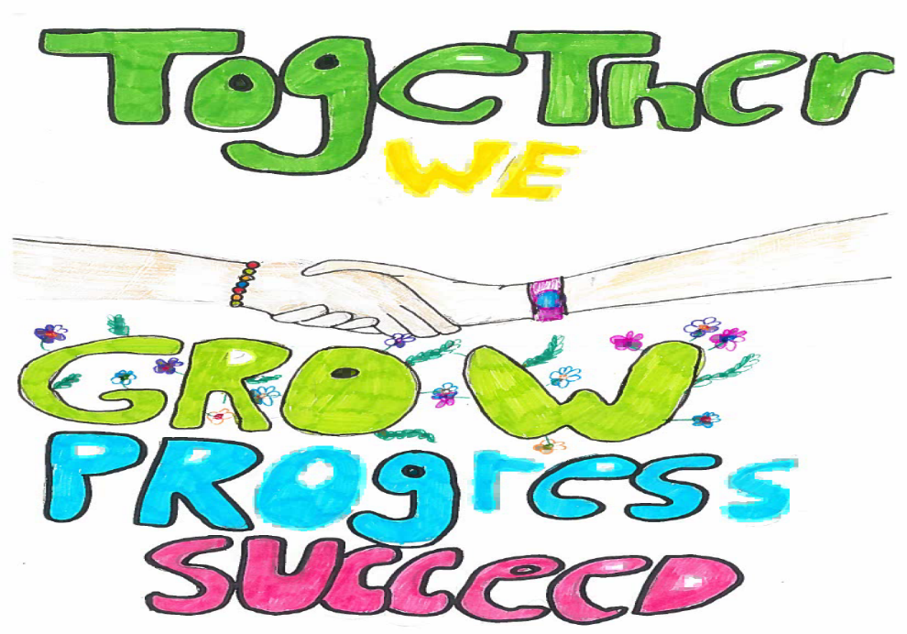

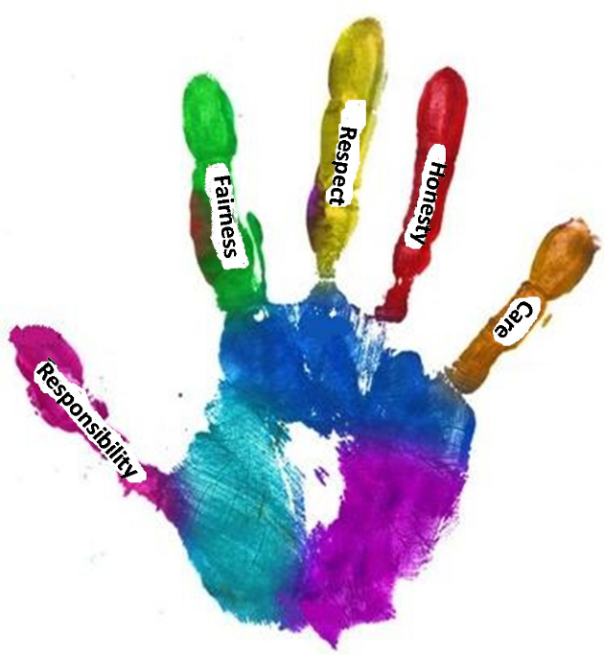

Considerations
For many of us, adults and children, the return to school will be greeted with a huge sigh of relief. We will all want to return to how it was, but we all have been changed by our experiences over the past few months. It will take time for us to return to the ‘new’ normal. If we place the Health & Wellbeing of our school community as our number one priority during the return to school this will put us in a strong position to ‘make up’ the lost learning that many are anxious about.

Social distancing and health and safety issues will be covered by appropriate risk assessments, actions and staff training, taking into consideration latest advise from Governement, NHS etc. It is impossible to predict what this will look like.

It is vital that we are vigilant in the first few weeks on the return to school of the individual needs of our learners, families and staff. This could be down to illness, bereavement/loss or the mental and social health of individuals and financial issues. We need to take the time to assess and repond to the needs of those in our community

It is important that a transition back to school involves a routine being established as swiftly as possible. Children will be tired so the planning and organisation of activities will need to consider this. Alongside this is the potential for sustained period of blended learning experiences in and out of school which will require a period of adjustment.

For many children, they will have become use to being with their parent and immediate family for an extended period of time. Even for those excited to see their friends and regain some freedom, this is a potential source of anxiety. There will be some children who will struggle with this separation anxiety.

Other issues may present anxiety for staff, parents and children. An example of this may be the fact that children have outgrown their uniform and parents may struggle to get new uniform for their child. Many issues like this will continue to be raised, with issues we have not thought about suddenly cropping up. It is important that we all work together, support each other and talk to each other.

The priorities and actions contained in this action plan are not set in stone and will be reviewed and adapted as appropriate. They detail the initial actions which will take place. After the initial actions contained in here are completed, more detailed focus priorities will emerge. It is important to note that the recovery period is fluid. We cannot plan for specifics at this stage.

Thank you for your continued support.

Jenny Glennie

Considerations
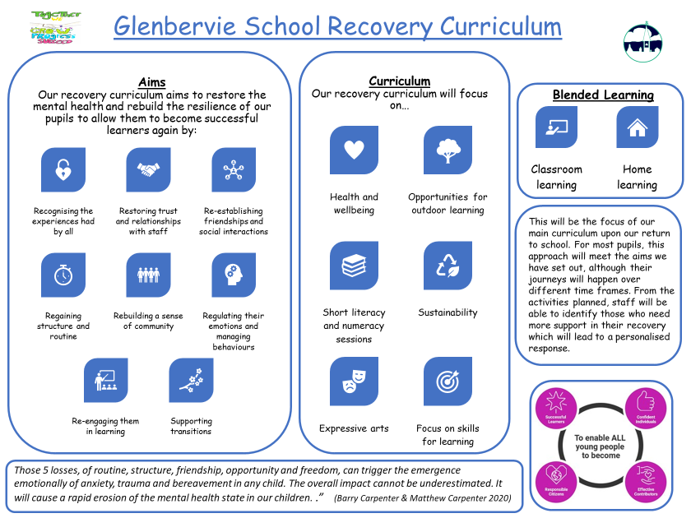
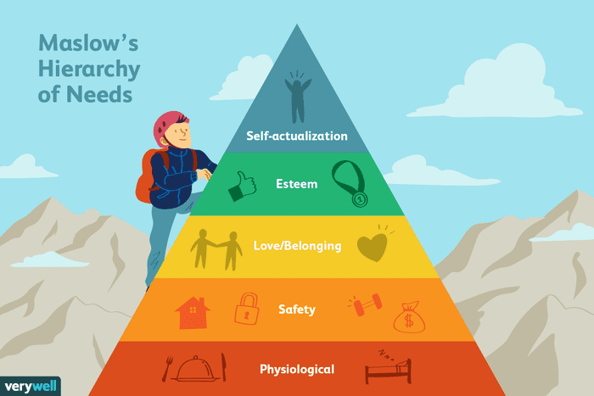
Maslow’s Hierarchy of Needs

Physiological – We have a duty to ensure our learners basic needs are met. Look out for hunger, tiredness.

Safety - Learners have to feel safe, both physically and mentally before they can learn. To apply this step of the hierarchy, it is essential to create a safe learning space.

Love/Belonging - Learners need to feel that they belong to a class. Games, group work and teamwork exercises are a way to apply this stage because interaction helps students feel more involved.

Esteem - Making learners feel that they are making a contribution and that they are valued as individuals can be done with simple praise: "Well done!" goes a long way

Self-actualization - Ensure learners unique skills and talents are showcased. Learners with particular skills and talents need be provided with opportunities to help their classmates.

Priority 1 Covid Recovery– Issues Relating to Staff Wellbeing
Evidence/Data Informing Priority | Covid Lockdown March-August 2020

Specific Actions & Interventions | Who?  Q.I. 1.3  Leadership of Change | What impact will be measured? | Progress | Actual Impact  How do we know?  Progress & Next Steps
 |  |  | Complete
 |  |  | Ongoing
 |  |  | No Prog.
Decisions regarding the ‘safe’ reopening of our school are agreed as a collegiate team where all issues are discussed in open and transparent environment. Opportunities for frank discussions allow staff to share concerns and seek reassurance.  HT to ensure risk assessments, operating procedures and their impact are agreed and fully understood by ALL staff. | HT | ALL staff are comfortable with and understand the safety measures and interventions in place. | By Sep 2020  Then Ongoing | At every Collegiate, staff review and agree the RA to ensure they are comfortable with safety measures in place. Reviewed regularly as a team so happy with measures.
HT to ensure staff meetings are an opportunity to focus on the wellbeing of staff.  ALL staff are provided with individual time to talk with HT regarding their own wellbeing, experiences and will be signposted to any support available. | HT | ALL staff feel supported, motivated and able to perform their job in these challenging times. | By Sep 2020 Then Ongoing | Staff wellbeing is key- Inset Day took outside and check in cuppa/chats happen regularly at end of day. Further offers of support have been made by authority to support bereavement and staff sign posted to this.
HT to ensure staff workload is minimised during the recovery period with no formal expectation on planning, monitoring and CLPL.  HT to ensure ALL staff “go home” at a reasonable time to focus on their family members and own wellbeing. Use Walk Out Wednesdays etc to support this. | HT | ALL staff settle back to a routine well.  No evidence of staff burn-out. | By Sep 2020 Then Ongoing | Staff are working hard to set up new routines, but are able to slow down pace of learning in line with recovery. Many staff are leaving at reasonable time and NCCT has supported this, but some staff including myself need to get better at balancing work-home balance.
HT and Class Teachers agree and understand the expectations regarding managing the ‘blended’ learning of pupils when in the class and when at home should this be necessary. Modify WTA in response to this consulting Trade Union guidelines. | HT  Staff | ALL staff ensure a consistent and equitable approach across all stages in the school. | Ongoing | HT/staff have prepared for blended learning and have reviewed lessons learnt from Distance learning to support if this becomes necessary. WTA reflects this.

Priority 1 Covid Recovery - Issues Relating to Learner Wellbeing
Specific Actions & Interventions | Who?  Q.I. 1.3  Leadership of Change | What impact will be measured? | Progress | Actual Impact  How do we know?  Progress & Next Steps
 |  |  | Complete
 |  |  | Ongoing
 |  |  | No Prog.
All staff to receive refreshed safeguarding briefing on return.  Assess learner’s social and emotional needs in the first few weeks by planning and delivering open activities; talking, play and enjoying the broad curriculum.  Adopt a dialogic approach - listening, talking and observing as a first stage in gathering formative information about children and young people’s learning needs on their return to places of learning  Use Health and Wellbeing Assessments to gather information from pupils and parents.  The “formal” curriculum focus will be on Health & Wellbeing, Literacy and Numeracy only during term 1 with opportunities to learn outdoors maximised using opportunities for IDL. | Staff/HT | ALL staff feel confident to respond to disclosures/observations/concerns effectively.  ALL staff build up a holistic picture of the needs of learners enabling interventions, support, challenge to be planned.  Use previous years’ forward plans, previous assessments, learning activities and tasks - including those carried out during the period of remote learning - to support initial assessment of learner progress.  Use of engagement in learning evidence used during lockdown to support gathering of information on children’s learning.  Baseline and follow up assessments to any bespoke programme of work which may be put in place for a short period of time to reinforce different areas of learning for some learners | By Sep 2020  Then Ongoing | Staff training on CP completed, alongside Nurture training and information from EPS team.  Staff through discussion and observations have built up picture of needs on return.  Evidence of engagement & Baseline assessments have helped all staff identify priorities/interventions and allocate staff support/resources accordingly.
Re-establish routines by allowing for a period of adjustment by acknowledging the challenges this may bring. Support families and individuals to do this (it can also be for those basic daily routines such as sleeping and getting up).  Visual timetables used universally in all classrooms. | HT  Staff | ALL members of the school community feel equipped and supported to re-learn a new rhythm of school and daily life. | By Oct 2020 Then Ongoing | All members of school community feel supported and equipped sufficiently to new routines. Will monitor and adapt as necessary.
Re-establish the school vision, values, relationships, ethos and expectations. Staff to ensure children’s learning experiences have a focus on how we treat each other and on re-building relationships, creating a safe environment and re-creating the positive culture we had. | HT  Staff  Learners | ALL members of the school can articulate our vision and values and why they are important in our school. ALL learners feel safe, included and nurtured. | By Oct 2020 Then Ongoing | The VVA aims has been reinforced through Virtual Assembly, class charters and communications with parents.  Our SHANARRI survey and nurture group work indicates that all feel safe & included.
Ensure the sensory needs of our learners are considered. The hustle and bustle, movement and interactions with many people in school may be difficult for children to adapt to after spending extended time with immediate family only. | HT  Staff | ALL members of staff aware of sensory/individual needs and make use of Nurture Space and support staff for those having difficulty. | Ongoing | Staff have information and daily chats regarding individual needs. Nurture group runs x2 weekly and additional support including team teaching , PSW in place.

Priority 1 Covid Recovery – Issues Relating to Parent/Carer Wellbeing
Specific Actions & Interventions | Who?  Q.I. 1.3  Leadership of Change | What impact will be measured? | Progress | Actual Impact  How do we know?  Progress & Next Steps
 |  |  | Complete
 |  |  | Ongoing
 |  |  | No Prog.
In partnership with Glenbervie School Partnership, plan a series of virtual informal events to renew our school partnership. When restrictions ease then develop further. (Coffee events, HT drop-in sessions*) to ensure the momentum and working relationships which was established are quickly re-established.  *Following Guidance regarding social distancing etc | HT  Staff  Learners | ALMOST ALL members of the school community feel included and involved in the life of the school. | Ongoing | To date questionnaires by Forms indicate that almost all pupil/ parents feel included. Communication through Seesaw, social media has helped support this.  Virtual P1 info session & Shared Learning Videos has helped involve all as cannot enter building.
Revisit our previous work on the Cost of The School Day to signpost families/individuals to the initiatives in place at Glenbervie to reduce the cost of the school day. Remind families of Free School Meals Provision, School Clothing Grants etc. which provide financial assistance, | HT  Staff | ALL members of the school community are aware of how to seek help, support and advice. | Ongoing | With GSP have revisited Cost of School Day. Information has been sent out regarding supports that are available.  Uniform/Jacker swap shop has been set with Covid procedures.
Ensure parents are actively involved in the GIRFEC process (assessment, identification and action planning) where interventions are required.  Ensure parents are regularly updated by school staff. | HT  Staff | ALL parents are involved in building a holistic picture of the needs of learners and are aware of and understand interventions and supports in place. | Ongoing | All parents have used the Health & Wellbeing Survey to be involved in GIRFEC processes. Further supports either through ASL, EPS, SALT, PSW have all been accessed and discussed with parents.
Ensure parents are signposted to help/support for a wide range of issues (health/bereavement/financial) by working closely with CLD. PSW, EP and SW Colleagues. | HT  Staff | School can signpost parent/carers to help and assistance in the community. | Ongoing | Admin Team, EP, SW and Council have all signposted supports through email and Social Media to families.

Priority 1 Covid Recovery – Issues Relating to Transitions
Specific Actions & Interventions | Who?  Q.I. 1.3  Leadership of Change | What impact will be measured? | Progress | Actual Impact  How do we know?  Progress & Next Steps
 |  |  | Complete
 |  |  | Ongoing
 |  |  | No Prog.
Soft start bringing in P1 in for a session themselves in week 1  Continue Seesaw engagement and activities if needed.  Allow new children to have half days until the end of week 2.  Hold Primary 1 induction meeting virtually with parents and send out information packs. | Staff | Primary 1 learners continue to forge trusting relationships with staff.  Primary 1 parents feel confident and supported as their child starts school. | By Oct  2020 | P1 settled extremely well with no separation anxiety. Links with Seesaw during lockdown helped build good relationship. Daily playground greeting with HT/Staff helps, as did Virtual P1 induction and distanced visits at end of Term 4.
Ensure last years Primary 7 parents have been provided with good quality information to enable their child to settle into secondary school.  Continue to engage with Seesaw for Week 1.  Transition planned with Mackie Academy. | HT  Staff | Last year’s Primary 7 learners have a sense of closure by receiving a fond farewell by the school.  Primary 7 parents feel confident and supported as their child starts school. | By Oct  2020 | P7 were supported fully in transition by primary and academy through excellent transition resources online and in staggered small group entry. P7 teachers have stayed in contact to support throughout T1 and all have reported good experiences and confident children.
Close Liaison with CT from 2019/20 and collegiate approach to support missed transition visits to 2020/21 class.  Continue to use Seesaw to share information and engage parents | Staff | Learners and Parents feel confident and supported as their child starts new stage. |  | Excellent Collegiate working and Seesaw has meant all children and parents have had a smooth return. Any who need extra support have been identified and supported. Seesaw continues to be used well alongside school communication to engage and support all.

