P5 Newsletter TERM 1 2020-21
A huge HOORAY and welcome back primary 5! I hope you all had restful summer break and are ready for another busy school year full of fun and learning!
It has been a funny kind of year so far but let’s hope our new normal with be smooth running and we can make the most of our school experiences. I am looking forward to rebuilding positive relationships with you, focussing on Health and Wellbeing, and as we get used to our new routines we will build on our learning. We will continue with Visible Learning as a whole school approach, with focus on giving effective feedback and encourage independence and reflection on learning.
The outline of the school year will look a little different, however please don’t hesitate to contact me through Seesaw, phone call or email if you have any questions.
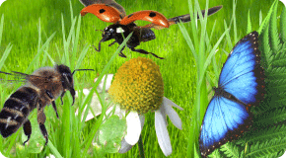
Topic
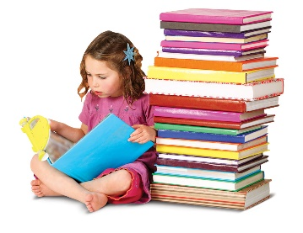
This term we will be learning about minibeasts and lifecycles. We will be utilising the outdoors as much as possible, so please make sure you dressed in comfortable and appropriate clothing. Within this topic we will be investigating the lifecycles of insects and plants, looking at what the need to grow and their habitats. Through this we will develop range of skills, such as, observation, investigation, research, co-operation, problem solving and leadership.
Reading
Reading this year will be based on a book detective programme, which the pupils are responsible to read their book and take on a variety of roles. These will be discussed once a week in your group with CT. We will also be using literacy box for comprehension tasks. They are welcome to borrow books from the school for a silent reader. Each group will read twice a week, please make sure you have your reading books in your bag each day as we often use them for follow up tasks.
A grid will be sent home regarding homework with a variety of weekly and termly tasks. Weekly homework will be set on a Monday and will include reading, spelling and mental maths. You will be given a jotter to work in, however this should not be brought back to school. Any completed tasks should be uploaded onto Seesaw and you will receive feedback this way.
Diaries
You will be given a diary this year and you should bring this with you each day, keeping it in your own tray. I will be encouraging you to make sure your own diary is kept up to date and that you record reading tasks in this.
Logins for websites will be in the Home School Diary.
We will be continuing to use Seesaw to share learning, especially homework. A new set up will be in place and more information will be sent out on how to archive last year’s work. Pupils will be given a new QR code for their new classes and steps on how to access this.
P.E
Pupils will not be getting changed for P.E and will not require a kit. All P.E will take place outside, therefore, on P.E days you should come dressed in comfortable trousers (leggings/joggers) and trainers. Your school t-shirt and jumper will be fine.
Forest Schools
Every second week we will have forest schools. You should come dressed in the morning in appropriate clothing that you do not mind getting mucky.
Dates as follows:
Tues 25th of Aug
Tues 1st of Sept
Tues 15th Sept
Tues 29th Sept
Water bottles and packed lunches
If you choose to bring a packed lunch it will need to remain in your school bag until lunch time. Water bottles will be sent home each day and returned each morning. Please could bottles please be filled up before school. We would prefer it if we didn’t have to hand out cups.
I hope this is useful to you and feel free to contact us through the Home School Diary with any further queries.
Best Wishes,
Miss Houston

