Hello and welcome to P3/4. We hope you have all enjoyed the Summer break and are as excited us we are to be back in the classroom!
This short newsletter along with the information already provided from Mrs Glennie will explain some of our learning and routines for this term.

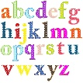
Literacy

Pupils this term willl be reading and studying the novel ‘The Twits; by Roald Dahl. If your child has their own copy of this book at home, we would ask if possible if they coould bring it in (with their name on it) to remain in school whilst we are reading it. The book will stay in their own tray and only be used ny them.
There will be no set reading homework this term, the childrem will have lots of opportunties in class for practisng their reading skills.

Spelling will begin with revision of sounds that have already been taught. P4s’s will then begin a new 4 week rotaion which will include sounds, spelling rules and spelling strategies. Spelling for P3’s will be similar to before but with new sounds.
Spelling homework – P4’s will be set homework on most Monday’s, depending on rotation. P3’s will be given their homework on a Thursday. Both will be due to be submitted for before the same day the following week. To minimise the hadnling of items from home, we kindly ask that homework jotters remain at home. Once your child has completed their homework for that week, it is to be uploaded to Seesaw for us to give feedback.

Numeracy
This term we will be looking at further developing the children’s understanding of addition and subtraction. As well as this, the class will also be learning about fractions.

Topic
Our priority this term is to settle the children back in to school life. Through various Health and Wellbeing activities we hope that the children will feel safe and excited to be back in the classroom with all their friends.
Later in the term, we may begin to look at the topic of electricity.

Equipment

We kindly ask that no toys or unnecessary items are brought into school from home.

Pencil cases can be brought in, but these will remain in school in your child’s tray and should not be taken home.

PE – PE kits will not be required as no changing will take place. However, as PE will only take place outdoors, a change of shoes can be brought in.

Water bottles – These can be brought to school on a Monday and remain in school until Friday when they will be sent home to be washed.

Reading bags- Reading bags can be brought in but will remain on their pegs in the cloakroom. Each child will have their own tray where they can put their money/snack.

Forest School

Forest school will be taking place every 2nd Tuesday starting on Tuesday 18th August. Please can your child come to school on these days dressed for forest schools. A change of footwear will be required. A change of clothes can be brought in for after, however we are hoping that it will not be necessary to change.

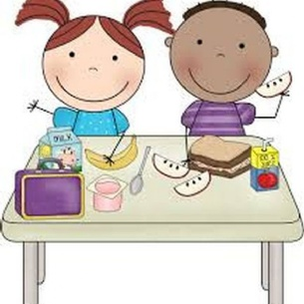
Lunch

If your child is to be staying for a school lunch it would be helpful if you could each day let them know the choices before they arrive in school. Alternatively, a packed lunch can be brought to school if your child prefers.

School Drop Off and Pick Up

Please see email from Mrs Glennie regarding details for this.

Communication

Again, to minimise staff having to handle items from home, children will be responsible for writing in their own homework diaries. This also means that they will not be checked by us daily for messages. If you wish to contact us or have information to pass on please do so either via Seesaw, email, or a phone call to the school.

We look forward to working in partnership with you and would like to emphasise that if you have any questions/queries or concerns please do not hesitate to contact us via email/phone/Seesaw.

Regards,

Mrs Cerretti and Mrs McConachie

