Parents Night Review & Shared Learning Events- November 2019,
October 2019 & February 2020
Thank you so much for your attendance at our parents evening. We again had a 93% turn out over the two evenings which was fantastic. Our online booking system continued to work well, with most parents gaining an appointment which was suitable for them. There were one or two queries, but if you required support the staff here at Glenbervie were happy to help. It was lovely to see so many of your children with you- sharing in the learning conversation. Please remember we have an Open-Door Policy here at Glenbervie, so if you have any queries or concerns please do not hesitate to come in.
Our Sharing in the Learning sessions were popular but had mixed attendance. The Literacy session in October which was first thing in the morning had a 72% attendance rate, whereas our Numeracy event in February had only 61% attendance over the 2 afternoon and evening sessions. We had altered the times of the events over the year in response to feedback to try and accommodate all parents working and non-working. We have taken further feedback from these events and will continue to use this to improve.
Our Children have also been completing surveys and focus groups to help us with our improvement plan progress. Staff, pupils and parents will work together on next steps.
We also had three other Dotmocracies gathering views on School Improvement. We asked about charities and how school money should be spent. We also had a focus on our family learning and what kind of events you would like to participate in. Finally we asked about reporting styles- what you liked and any comments. So in true “You Said, We Did” here is a summary of your comments/results and what we are doing about it.
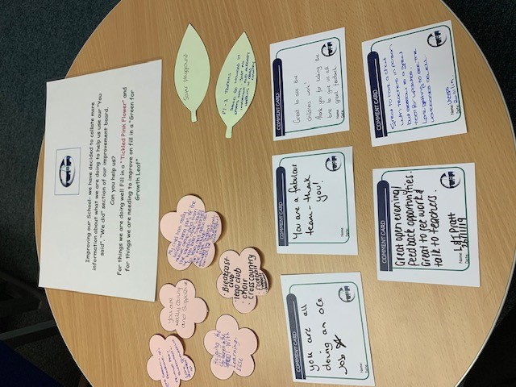
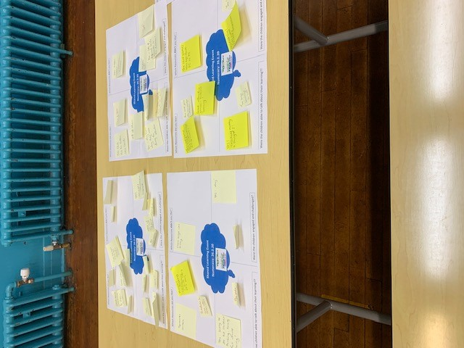
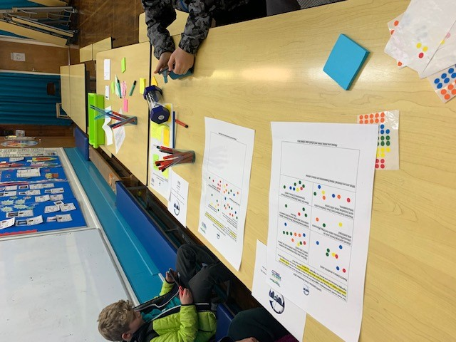

“You Said” | Our Response and  “We Did” “We are doing”
Reporting:  Of the survey results seesaw was the most popular way of reporting with 16 responses, followed by meet the team and Formal parents evening with 10 responses.  Written reports, school events and overviews had responses of between 7-9, but interestingly only 3 people saw Shared learning events as a way of reporting, yet this is something families indicated they wanted more of last year.  Seesaw Comments- “ Finding it very easy and convenient to use, can access as an app”  “love that can see in real time how may children are doing and discuss it”  “ Great to see all the fantastic things going on at school.  “ would like more information on its purpose and how it is used” | Great to hear- our children love seeing and hearing your comments back. It is a great tool for involving you in the learning, assessments and life of the school. All staff are using it more and we are gradually upskilling our children to use it independently. Assessments and reflections are now being shared on seesaw too to keep you updated on progress and next steps.  Attached to this email is an information sheet on Seesaw which was handed out at the Learning Event. Please ask if we can help further as our aim is to have all families and children on seesaw as this will be the profile of reporting.
Family Learning Sessions:  Parents indicated that they would like more sessions. The most popular was supporting Learning needs and the Role of Speech & Language with 10 responses each. Digital skills and using Seesaw had 7 responses and next was ways to support with Literacy and Numeracy at home with 6 responses.  “It would be good to know what these people do to support my child and get tips on what I can do at home”  “I would like a better understanding of how areas of the curriculum such as maths. Literacy and health are taught”  “It would be good to see the resources children use and see where I can help at home”  “Be good to get a parent digital skills session as my children know more than me!”  “Don’t think we should have homework” | We held an ALEC parents’ session to share how we teach Health topics using these resources. This was conducted by the Aberdeenshire advisor on this in the tent used to present to the children.  We have had two sharing in Learning sessions to share how we teach Literacy and Numeracy. Literacy had better attendance. Feedback was all very positive and the children enjoyed challenging some parents with activities!  The Pre-school and school ran a joint event about the importance of play in learning and planned on 26th March 9.15am have a parent only session at the Village hall to share the role of Speech & Language and how you can help at home.  Our Additional Support for Learners Team Mrs Brown, Mrs Collett (IPT) and Catriona Masson (PSW) hope to have a joint information morning to share their roles and what they do to support children in the school. More info will follow.  Homework- Whilst we appreciate there are mixed views, we did a full consultation on homework with parents last session 2018/19 and the consensus was to keep homework, but not overload our pupils. We also agreed in summer term to try and reduce the amount given to allow children to play outside.  The agreement was that homework should not take more than half an hour, but to build the independent learning of our pupils. It has been commented on by Mackie that pupils coming up are struggling with homework and deadlines as many schools have opted out. For our senior pupils it is about adopting skills for life and work and we currently feel this is vital to support the transition to the academy.
How the Money in school, both of Charities and GSP, should be spent.  “ Reach out to families and pupils for an input and perhaps vote”  “ I trust the school and GSP to spend the money wisely”  “I personally feel the school should advise on the area they need the most”  “All money should go to school or multiple choice to chosen charities”  “I think the money raised should be used solely on the school and if a charity chosen could it help local committees such as DIG for a new little park” | We had a suggestion sheet and comment page out at Parents Evenings in November for parents and pupils to nominate charities we should support, but no responses were made, with exception to those on the left.  This year given the fact our budgets are very small our Pupil Council have opted that the Sponsored walk should be to benefit the school. Parents and staff have indicated this too. Our charity contributions will continue through the Community cafes, which again will be decided by pupil voice.  The GSP agreed to give £2000 to the school this year to spend on what the school feel is appropriate. This was not requested by the school, but a decision made by the GSP committee. All minutes/agendas/spends are shared are shared with all parents so there can be the opportunity to comment and feedback. Key contacts are Dawn Campbell- Chair, Yvonne Baddeley- School issue liaison and Claire Ramsay- Fundraising liaison.  Money so far has been spent on Whole School Pantomime trip, Espresso Educational subscription, Christmas Crafts and contribution to Digital skills Specialist.
GSP “Raise awareness of GSP”  GSP- where do you feel the money should go?  “School transport & other things relevant to the curriculum”  “Support for teachers in classrooms”  “ visiting specialists e.g Art, dance”  “Trust staff to identify where the needs are greatest”  “class trips and resources” | The GSP are trying very hard to Raise Awareness of what they do and how you can get involved. The P1 Induction starts this off and my termly newsletters support their work.  The GSP have themselves started Newsletters and provided information of how you can contact them. In terms of sharing what the money has gone towards – I will suggest the GSP include this in their newsletters, as I try to do.  As a partnership group the school has always requested to GSP by email or in person what they wish money for and always tries to indicate the GSP contribution in our letters, which we will continue to do.  These comments and suggestions are all valid and we will look at them with the GSP at our next meeting  This will help when as happens every year a wish list is given by the school and the GSP vote on how much they can support.  The parents and staff of the school try very hard to support all GSP events organised and we would always appreciate any support including time any of you can give. We will continue to share information regarding meetings and hope you can join us or have your say in surveys we put out.
What a marathon response- but I hope this gives you some indication of the huge amount that goes on for the staff team, our parent partnership groups and community partners.
I try to do this “You Said, We did” (our response) feedback twice a year, but please don’t wait for these events- take advantage of our Open Door Policy and come and speak to us.
With Very Best Wishes,
Jenny Glennie
Head Teacher

