 

**Parents Night Review- November 2018**

Thank you so much for you attendance at our recent parents evening. We had a 92% turn out over the two evenings which was fantastic. Thankfully our new online booking system seemed to work well, with most parents gaining an appointment which was suitable for them. The positive feedback on our Dotmocracy indicated that the online system was received well, fairly easy to use and if you required support the staff here at Glenbervie were happy to help. It was lovely to see so many of your children with you- sharing in the learning conversation. Please remember we have an Open Door Policy here at Glenbervie, so if you have any queries or concerns please do not hesitate to come in.

We also had two other Dotmocracies gathering views on homework, charities alongside our usual feedback slips and sticky notes. So in true “You Said, We Did” here is a summary of your comments and what we are doing about it.

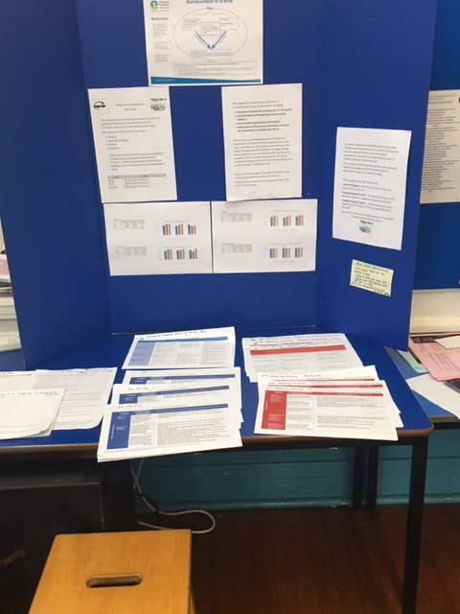

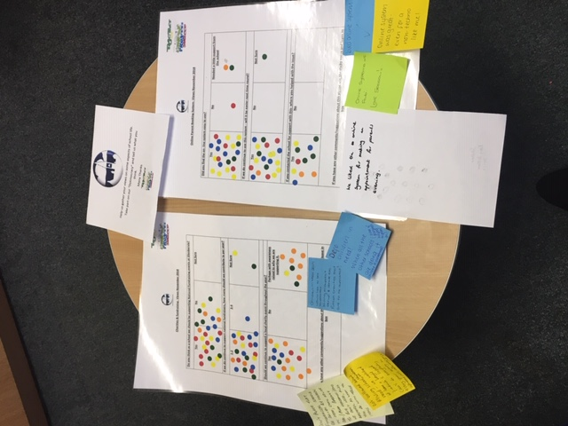

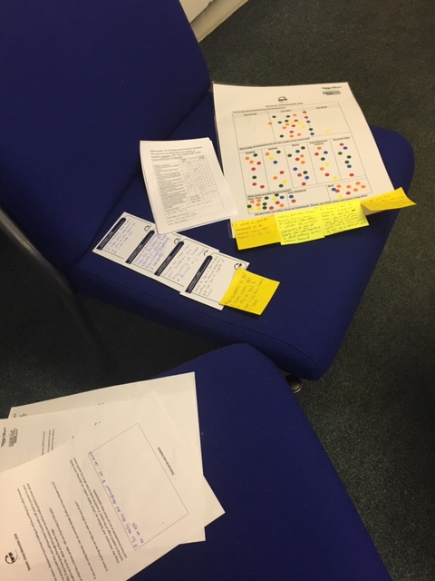

|  |  |
| --- | --- |
| “You Said” | Our Response and  “We Did” |
| **Seesaw-** “ Finding it very easy and convenient to use, can access as an app”  “Very easy to use, enjoy being able to easily access the app from my phone” | Great to hear- our children love seeing and hearing your comments back. It is a great tool for involving you in the learning, assessments and life of the school. All staff are trying to use it more and we are gradually upskilling our children to use it independently.  From next week you will also be able to see photos and video-clips of your children as all the relevant GDPR permissions have been approved at authority level. |
| **Online Parent- Evening-**  “We liked the online system for making appointments for parents evening”  “online systems were great- even for a non-techno like me! | Our admin team are delighted you liked it. It significantly reduces their time spent organising appointments, sending out times and negotiating with CT if you have more than one child.  We will be using it again in May. Our team will continue to support you with the system. Please do not hesitate to contact them.  It is the same system used at Mackie so for our P7 parents will allow a smooth transition. |
| **Homework-**  “Working full time means my family time is weekends, after fitting in activities” Family time is important to child wellbeing rather than homework”  “No time for homework is ideal”  Not keen on the spelling activities-can be frustrating and time consuming”  “It would be good for homework to be marked every week with a tick or smiley face” | The Dotmocracy indicated that most parents though we had the right amount of homework, only 1 person indicated there was too much. All homework was supported and Mon- Thurs and both over the weekend & Mon- Thur scored highly.  Mrs Glennie will put on staff meeting agenda and discuss comments that were made.  We are reviewing our Homework Policy currently and will take into account your views and comments when looking at what we do at each stage, how much and what you feel is important. We will also have it on the GSP agenda to gauge further feedback and thoughts. It will be shared for approval.  Thank you to all of those who took the time to fill in General survey- again these comments and scores will be most helpful. |
| **Charities-**  “Children in Need 2019 would like to see supported. Willing to set up, donate etc.  “Publish charities that are to be supported”  “Defo Children in need- when other schools are doing it. (even if parents helped to plan/do”  “Don’t agree that fundraisers should be driven by Children in Need, Comic Relief. Pressure to buy headbands, noses etc we don’t need- wasteful”  “Not bothered about school missing these out- we can watch at home and can support if widhto by buting products. Can’t do everything every year as already do Sponsored walk, raffles etc.”  “ Just emailed to say I fully support your approach and email sent today” | We always indicate charities that are to be supported in the Annual Calendar at the start of the school year, so people are aware. Our sponsored walk is the only one we decide closer to the time, but date is given.  This was a split dotmocracy with a 55% 45% vote regarding National Charities, with the Yes just winning. On this note I will take it to GSP for further consideration. As suggested in my previous email- we should perhaps go for an opt in, donate a £1 as some of our cluster schools do and then if further events want to be organised we can look at parent/ pupil group support, but again with participation optional.  For local charities there was a strong Yes 100% support, with many indicating they would like raised awareness of why we have chosen it like we did with Gathimba Edwards, Cancer Research in the past. |
| **General Comments left**  “Good to have face to face meetings like this to discuss progress and find out how to support at home”  “Great to hear how children are progressing at school and discuss any issues”  “ Nice and relaxed, Good acess to the school work and opportunity for children to play/draw and show us their school work”  “ Really enjoying hearing how the children are getting on and seeing them achieving and progressing (&behaving!)”  “Would like to know more about what children need to do to get a level”  “Less focus on sport and more non sporty activities”  “ Choices where money spent e.g Active Schools” | Great to hear so much positive feedback regarding our Parents evenings. We have been changing the format for the past 3 years, moving from the traditional parent only and sit outside the class waiting to see the teacher. These New Improved Reporting approaches have given children more involvement in learning and allowed parents time to look at work, chat to other families and time to participate in feedback on the school.  In terms of achieving a level for the past 3 years we have been asked to submit our attainment information for Achievement of a Curricular Level (ACL) to the Scottish Government.  We report on 4 areas of the Curriculum: Reading, Listening & Talking, Writing and Numeracy. Education Scotland provides support in this to ensure our information is robust and reliable. The box below indicates very broad guidelines of expectations of progress from Nursery to Primary 7. Please note however that all children develop at their own pace and will be supported to do so.   |  |  | | --- | --- | | Level | Stage | | Early | By the end of Primary 1 | | First | By the end of Primary 4 | | Second | By the end of Primary 7 |   The judgments of these levels come from a comprehensive range of information including;   * **Education Scotland Benchmarks for P1, P4 and P7** * **School and Aberdeenshire Progressions & frameworks for Nursery-P7** * **Scottish National Standardised Assessments (SNSA’s)** * **Class Teacher Assessment Information** * **Observation of children’s work** * **Holistic assessments that look at the Breadth, level of challenge and application of learning.** * **Moderation of these Levels with other local schools to ensure the information is reliable and robust**   At Parents Evening we provided information around this and also copies of the Benchmarks and progressions. It is important to note, they are not used as a checklist, but children are looking to succeed at MOST of the benchmarks to attain a Level.  Staff are also in Meeting time looking at their moderation practices to ensure consistency in approach not only in our school, but across all schools. This is part of our Professional development.  Our ACL has been good over the last 3 years, but we never become complacent and are always moderating and looking at improving our learning, curriculum and approaches in these areas. The teachers use the Aberdeenshire Progression Frameworks to ensure that they progress from Early- First – Second level. The children are becoming more aware, through Learning Intentions & target setting, about where they are at and what they need to do to progress in their learning. As part of our SIP we are working at making this more Visible to the children and parents through “Visible Learning”.  It is worth noting that the hardest jump comes when children move from Early to First and First to Second as they are moving forward onto a new 3 year programme, although some attain earlier or later as children develop at their own pace.  This is when we find most interventions take place and staff discuss progress with the Head Teacher so appropriate supports can be put in place.  These Supports can take the form of;  **Univeral Support**- Brain box tools and ICT they can access in the classroom  **Targeted Support Level 1**- as Universal &Support from PSA, ASL Teacher or Supported programme of work.  **Targeted Support Level 2**- a Universal & Level 1 plus support from IPT teacher, PSW, Individual Education Plan (IEP)  Glenbervie is proud to be a Gold Sport Award School and will continue to be. This has only come about over the last 3 years at the request of pupils and parents. Our Sports and Health committee (pupils) have worked exceptionally hard to lead and support this. The netball, football, cross country, sports hall badminton and volleyball team are important to many of our children and in every pupil survey they will always indicate they want more! The social, emotional and mental wellbeing of Sport and Physical activity is very important, although we do recognise a balance of activities is necessary.  This is why we have Friday activities with a huge range of alternatives such as baking, sewing, construction, board games, arts and craft and garden gang to name only a few.  We promote Expressive Arts through our show, nativity and Burns Events over the year. We are very fortunate to have the talent of Miss Stephen who leads the choir and has done successfully for the past year.  The pupils themselves lead lunch time clubs such as Book Club, Dance Club, Euro Quiz Club and have the Bunny Rota. We welcome any suggestion and try to support this.  We have been very fortunate to have the introduction this session of Lego Club thanks to Parent Volunteers and Mrs Sangster. Again any parent wishing to share their time and expertise would be most welcome for existing clubs or new ones.  Active Schools is Active Schools is a key element in the Scottish Government's drive to get more Scots, more active; a commitment outlined in the national physical activity strategy [Let's Make Scotland More Active](http://www.gov.scot/Publications/2003/02/16324/17895).  The fundamental aim of the Active Schools network is to offer school aged children the motivation and opportunities to adopt active and healthy lifestyles. These opportunities are available before, during and after school, as well as in the wider community.  Active Schools also aims to introduce more physical activity into children's daily lives through active travel, play and dance. Our Active School team is therefore involved in several [partnership programmes](https://www.aberdeenshire.gov.uk/leisure-sport-and-culture/sport-and-fitness/active-schools/partnership-programmes/).  We have no choice than to be part of this and Active Schools costs a small amount of approximately £75 year. This used to be funded directly by Aberdeenshire but now comes out of our budget. Most schools opt to ask this parent group to help in this so the budget can be spent on jotters, pencils , paper, textbooks etc. I will take it to the GSP for consideration as the school always does.  The activities that our children benefit from for around £1 per head are: Rugby Tasters, Judo tasters, Street Dance tasters, Curling, Hockey tasters, Sports hall Badminton event and P4/5 swimming to name just a few and support the holiday activities that run. |
| “Raise awareness of GSP”  “ Be good to know where money is spent and have some say” | The GSP are trying very hard to Raise Awareness of what they do and how you can get involved. The P1 Induction starts this off and my termly newsletters support their work.  The GSP have themselves started Newsletters and provided information of how you can contact them. In terms of sharing what the money has gone towards – I will suggest the GSP include this in their newsletters, as I try to do. We will look at meeting of how regular these need to be.  We will also try to ensure agendas are shared prior to meetings and minutes shared after with all parents, this will allow everyone the opportunity to be involved and have a say. Perhaps these from meeting to meeting have not all been shared in the past, but we will try to do so from now on with our newly formed committee. The figures in the past been **have** been shared after our AGM and here is a summary of the spend/items bought since Mrs Glennie became HT.  **2015/16**  Science week- £455 Battle Scar History £150  Sports Bibs/Fleeces£430  Hopscotch theatre Company £234 (cost was £300- 44 pupils paid £1.50 each)  Christmas books & gifts £50.00 Cinema trip £382.30  3 class trips transport- £500 **Total £2650**  **2016/17**  Bounce back resource £150 Cinema Transport £380  Allan Magic Show £150 Christmas Craft £50 per class=£200  Tech fest science workshops- £237  Discovery education subscription£388  Knext workshops £295 Techfest P7 coach- £170  Trophies& awards £278.90- total was £578- school paid rest  **Total £2254.77**  **2017/18**  Techfest- whole school- £424.52  Rights of child £230 Class trips £500  Discovery Education Subscription £372.60  Christmas Crafts £200  Sound System £675.68  Awards & trophies £300 was nearly £580- school paid rest  **Total £2557.80**  As a partnership group the school always has always requested to GSP by email or in person what they wish money for and always tries to indicate the GSP contribution in our letters, which we will continue to do.  I will ask the GSP to put on agenda of next meeting possibility of designing a survey to be sent out all parents gauging a feeling of where they feel money should be spent. This will help when as happens every year a wish list is given by the school and the GSP vote on what and how much they can support.  The parents and staff of the school try very hard to support all GSP events organised and we would always appreciate any support including time any of you can give. We will continue to share information regarding meetings and hope you can join us or have your say in surveys we put out. |

What a marathon response- but I hope this gives you some indication of the huge amount that goes on for the teaching team, our parent partnership groups and community partners.

I hope to do this “You Said, We did” (our response) feedback twice a year, but please don’t wait for these events- take advantage of our Open Door Policy and come and speak to us.

With Very Best Wishes,

Jenny Glennie

Head Teacher

