Parents Night Review- May 2019
Thank you so much for you attendance at our recent parents evening. We again had a 92% turn out over the two evenings which was fantastic. Thankfully our new online booking system seemed to work well, with most parents gaining an appointment which was suitable for them. There were one or two issues with multiple appointments but if you required support the staff here at Glenbervie were happy to help. It was lovely to see so many of your children with you- sharing in the learning conversation. Please remember we have an Open Door Policy here at Glenbervie, so if you have any queries or concerns please do not hesitate to come in.

Our school online survey had 30 returns out of 53 families and a further 4 families answered on parents evening. The Survey is attached to this email. We will use all the results to look at what we do during the school year and use it to improve. For example it is looking evident we would like more shared learning sessions and more timely information on progress, feedback on how your children are doing. Staff, pupils and parents will work together on next steps.
Our Children have also been completing surveys to help us with our improvement plans for next year.
We also had two other Dotmocracies gathering views on School Improvement, linked to the questionnaires sent out by survey monkey. We also asked about charities and our Behaviour Policy in response to some feedback in the online survey. So in true “You Said, We Did” here is a summary of your comments and what we are doing about it.
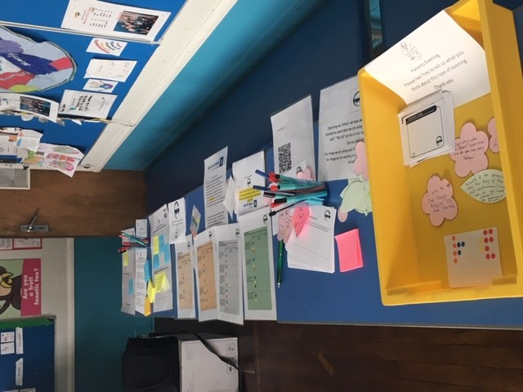
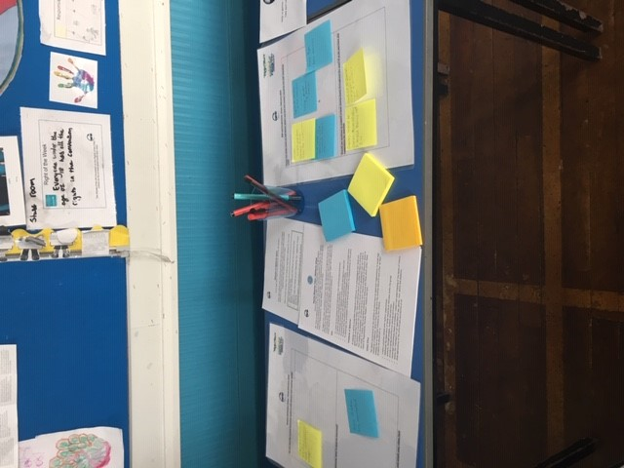
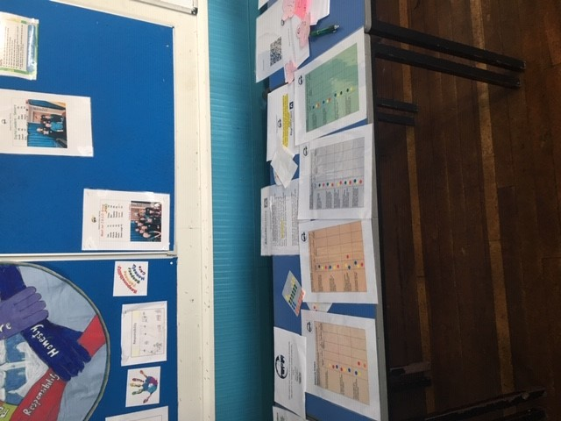

“You Said” | Our Response and  “We Did” “We are doing”
Seesaw- “ Finding it very easy and convenient to use, can access as an app”  “Very easy to use, enjoy being able to easily access the app from my phone”  “ Great to see all the wonderful things going on a t school, great conversation starter at teatime | Great to hear- our children love seeing and hearing your comments back. It is a great tool for involving you in the learning, assessments and life of the school. All staff are trying to use it more and we are gradually upskilling our children to use it independently.  Next session we will be using Seesaw- even further to share assessments with you and also to reflect on our learning similar to the way we use the Home- school Diary.
Online Parent- Evening-  “We liked the online system for making appointments for parents evening”  “online systems were great- even for a non-techno like me! | Our admin team are delighted you liked it. It significantly reduces their time spent organising appointments, sending out times and negotiating with CT if you have more than one child.  We will be using it again next session. Our team will continue to support you with the system. Please do not hesitate to contact them.  It is the same system used at Mackie so for our P7 parents will allow a smooth transition.
Behaviour Policy-  “Behaviour Policy is relevant but needs consistency in approach”  “There is a feeling within the children that not all behaviours are managed consistently. The behaviour policy is not used consistently and fairly. There appears to be a tension within some of the staff. Some of the younger children feel vulnerable with some of the bigger ones’ behaviour.” | The Dotmocracy indicated that most parents still feel there is a place for our Behaviour policy.  Mrs Glennie will put on staff meeting agenda and discuss comments that were made regarding consistency in approach and then backed up by HT. We all come together in our INSET Day to plan so this will be on the agenda.  We will also have it on the GSP agenda in future to gauge further feedback and thoughts.
Charities-  “Charities should be chosen democratically and benefit many, not a few”  “ Reach out to families and pupils for an input and perhaps vote” | For local charities there was a strong Yes 100% support, with many indicating they would like raised awareness of why we have chosen it like we did with Gathimba Edwards, Cancer Research in the past. We always indicate charities that are to be supported in the Annual Calendar at the start of the school year, so people are aware. Our sponsored walk is the only one we decide closer to the time, but date is given.  Our Pupil Council have a say in choosing the charity for our Sponsored Walk and always try to look for something close to home and relevant to the school. We always try to support something one of our staff or pupils have been affected by such as Cancer Research in recognition of grandparents that had been affected, Gathimaba -Edwards as Mrs McConnachie was travelling to Kenya and this year Cerebral Palsy in the form of Finlay’s Fund in recognition of our staff member. A percentage is given to the charity whilst the rest goes to school funds in our only school fundraiser of the year.  We had a suggestion sheet for this charity out at both parents evenings in May and November for parents and pupils to nominate charities we should support, but no responses were made. We will continue to do so and as suggested if there are a few to pick from we will put it to a pupil, parent and staff vote.
Extra – Curricular Clubs  “I have been a little disappointed with the decrease in after school activities over the past 2 terms, and the lack of information to parents about when/if they were to resume. Activities such as choir and lego club carer to the non sporty children and are better suited to the winter months. Maybe switch to outdoor activities in spring/autumn and then indoor over the winter. That would avoid issues with numbers and helpers as each would only be for 2 terms?” | Our Extra Curricular clubs are run purely on a voluntary basis by staff and parents. There are no obligations in contracts for staff to do this and it is about the goodwill of staff and parents willing to do this. Glenbervie is fortunate to have so many thanks to the staff and parents who give up their time to support. Football, Badminton, Cross- Country, Netball and Lego Club are the 5 clubs that currently run.  We recognise that many of these are sport related. Again any parent wishing to share their time and expertise would be most welcome for existing clubs or new ones that would cater to non- sporty children. Please just get in touch and we will be happy to support.  Choir did run for Term 1 and led to a beautiful performance at Christmas. Miss Stephen gives up her own time to do this for the school and has been unable to commit to this, this term. We try to communicate as effectively as possible regarding the clubs, but it is essentially up to the volunteers running these clubs regarding their capacity to run them.  We love the suggestion of splitting the clubs to Winter and Summer months, which would certainly help both the parents and staff volunteers. At the start of every year I put out a letter to gage interest so we will suggest this next session.
GSP“Raise awareness of GSP”  GSP- where do you feel the money should go?  “School transport & other things relevant to the curriculum”  “Support for teachers in classrooms”  “ visiting specialists e.g Art, dance”  “Trust staff to identifty where the needs are greatest”  “class trips and resources”  “ Be good to know where money is spent and have some say” | The GSP are trying very hard to Raise Awareness of what they do and how you can get involved. The P1 Induction starts this off and my termly newsletters support their work.  The GSP have themselves started Newsletters and provided information of how you can contact them. In terms of sharing what the money has gone towards – I will suggest the GSP include this in their newsletters, as I try to do. We will look at meeting of how regular these need to be. They are in the process of designing a survey to be sent out all parents gauging a feeling of where we can go as a partnership.  As a partnership group the school always has always requested to GSP by email or in person what they wish money for and always tries to indicate the GSP contribution in our letters, which we will continue to do.  These comments and suggestions are all valid and we will look at them with the GSP at our next meeting  This will help when as happens every year a wish list is given by the school and the GSP vote on what and how much they can support.  The parents and staff of the school try very hard to support all GSP events organised and we would always appreciate any support including time any of you can give. We will continue to share information regarding meetings and hope you can join us or have your say in surveys we put out.
General Comments- We appreciate every comment and suggestion that you make and will use this to go forward in our Improvement plan. Thank you for all the support.
“I would be keen for the kids to take part in the daily mile activity”

“change activities to different days of the of the week so can attend – not always a Friday”

“Thank you for all the hard work and support you all give my child and me as a parent.”

“You all do a fantastic and I thank each and everyone of you, from teaching staff and staff throughout the school. Your time, dedication and devotion goes above and beyond and it’s truly appreciated. Your support and open door policy is fantastic, nothing is too much bother and staff are always available. Well done Glenbervie! I wish there were more like you. Pupils don’t know how lucky they are.”

“We have not been here long but what a great wee school, lovely staff, polite and welcoming pupils -just love it! Thanks so much”

“We are so impressed at how welcoming the school is, how confident my child has become and how well the teachers know her. Love the chance to come in and see what they doing and seesaw great. Thanks!”

“Thanks for all you do- all staff know my children so well and care and look out for them. The experiences on offer are fantastic and I love the fact we get so many opportunities to come into school and share in their learning. A fab team in a fab school with a Head teacher who goes well beyond. Superstars!”

“My children are extremely happy at Glenbervie and the school is welcoming & clearly values every child. Thank you”

“Excellent school with outstanding head teacher and staff - they go over and above to do what they can to teach and support not just academic subjects but values and behaviours too. Feel we are very lucky to be able to be part of Glenbervie.”

What a marathon response- but I hope this gives you some indication of the huge amount that goes on for the teaching team, our parent partnership groups and community partners.
I hope to do this “You Said, We did” (our response) feedback twice a year, but please don’t wait for these events- take advantage of our Open Door Policy and come and speak to us.

With Very Best Wishes,
Jenny Glennie
Head Teacher

