Glenbervie School Partnership (GSP)
Meeting Minutes
25/04/19 Glenbervie School
Attendees: Dawn Campbell (DC), Councillor George Carr (GC), Jennie Glennie (JG), Angela Jamieson (AJ), Mhari Mitchell (MM), Aileen Davidson (AD)(minute taker).
Apologies: Christina Park (CP), Laura Heeps (LH), Lillian Cargill (LC), Odette Jones (OJ).
Item Number & Title | Discussion/Action | By/ When
Previous minutes

Agreed

Joint Chair’s Update

Quiz night was as success. Raised £500. Booked another for September 13th

Bunny Drive raised just under £500 and was well attended. Having it in the village hall helped as it was on a Saturday instead of an evening event.
There was a lot of feedback on having a bingo night. It seems to be better received in the village hall as when events are held in the school people think they need to have a connection with the school to attend.

Head Teacher’s Update

For the next school year we are staying with 4 classes. We have 10 pupils going up from P7 and 9 pupils going into P1. That keeps us at 73 pupils in total. Can’t provide detail of the classes yet.

In terms of staffing; Mrs Sangster is a permanent part of the team 0.5 and replaced Mrs Edwards and Mrs Cerretti is permanent 0.4 of team who has returned from Maternity leave.
We will continue with the same team next session slightly over staffed due to Mrs Cerretti’s return. Miss Stephen is entitled due to Aberdeenshire Policy to be offered a permanent contract in August as she will have been with us two years.

4. | Adoption of Constitution  Agreed to adopt the new constitution.  Plan to put this out with survey.  Email questions round to see if there’s anything we need to change. Ideally get this out in the next 2 weeks.  AD to put out a process for engaging in nominations etc for the start of Autumn Term. | AD  AD  AD
5. | Fundraising/Grants/School Request for Funding  Fundraising  Strawberry Tea date moved to the last Saturday in May (25th). (Following week is Dalguise trip). Hall is free on this date.  Can put out a change of date.  Christina, Mhari and Laura Heeps all planning to help out at this event.  This is the date of Auchenblae gala, and so it is planned to do the Strawberry Tea in the morning 10am-12 noon.  School Request for Funding  Kathleen Wilson has given an update of the School Request for Funding list (see Annex 1) for items needed for school. So far GSP has provided a cheque for the 2018 Pantomime and Support with Christmas Crafts and Discovery Education – Espresso Subscription.  A Request was submitted for:  - the money for the nativity costumes (£70)  - a dance session for health week (£120)  - the Gooseberry Planet software (£160)  - Money towards trips:  P2/3 Castleton (£100)  P4/5 CocoaOooze (£200)  P6/7 WWII (£200)  P1 have not put in their trip yet.  AJ confirmed that the GSP bank account currently has £3217 (see Annex 1). Nothing else is due to come out currently (see Annex 1).  £850 was agreed to be provided to meet the requested costs. £850 Cheque needed.  It was queried whether a new Tennis Court net could be funded. MH will ask CP as part of the community committee. It would be about £400.  Councillor Carr confirmed that part funding can be applied for from the Council Area Committee Budget.  Apply to Emma.storey@aberdeenshire.gov.uk. (the committee officer with responsibility for that fund).  JG also highlighted that they have a budget pressure on printing costs as they’ve only been informed of these at end of year (£2223). When this comes out of the budget it leaves the school only £600 for everything else.  It was discussed whether we could reduce printing on things like permission slips, but JG confirmed that for Health & Safety purposes the school need to have the physical copy to go out and about per trip. | JG  AJ  MH  ALL
6. | Parking  Fundamental Issue is that there is not much designated parking at the school. No traffic controls are in place around the school (no zig zag lines or flashing slow down signs). The junction coming out nearby the school (from the direction of Harvey garden) has lots of tractors that need room to swing round. There’s nothing to say where you can and can’t park. There are issues, not necessarily with parents but other people coming to the school and parking on the pavement. This stops kids being able to see to cross the road and causes issues with buses coming past the school for school transport. The school also uses the park which means crossing the road.  There’s been a few near misses.  We have tried:  - putting parking issues on Facebook to raise awareness  - kids going out with high vis and posters asking cars not to park next to the school  - promoting a one way approach (coming around from the park direction)  - promoting a park and stride from the other side of the park, but parents have highlighted that the parking area is too narrow to allow safe movement in and out of cars.  Councillor Carr detailed that this has been a long running issue and that one option was to look at an official one way system. He confirmed that Ewan Smith (the Principal Roads Engineer from the Council) or his predecessor came to the school in the past and we did look at some options and got some signage.  JG confirmed that PC Mark Camus came to the Community Meeting previously and Alison Meston raised the parking issues and he was surprised we didn’t have any road markings.  Councillor Carr confirmed that PC Camus has ticketed where parents won’t cooperate at other schools.  Councillor Carr identified:  - there’s a ward meeting on Tuesday. In anticipation of this Councillor Carr has put the school’s parking issue on the agenda. Ewan Smith will be at this meeting also, which will allow Councillor Carr to get his official views of what can be done.  - we need to look at what we can get as part of legislation. There’s signage we can look at. He will also ask about zig zags.  - there is criteria about flashing lights, it depends on school and road. On a main road flashing lights are higher up the priority scale.  - double or single yellow lines were looked at previously but could be looked at again.  - would also need to involve education department and roads too. Will ask Roads first for advice.  - Statutory Consultation may need to be undertaken and Community Council and local houses would have a say too. If houses are all quite happy with proposals then that could help too.  A query was raised about whether there’d be an expectation that the School/GSP would need to fund these traffic calming measures. Councillor Carr identified that he’d expect the Council to fund this. There’d be a cost of statutory consultations to accommodate.  Councillor Carr will try and give us a report back on what Ewan says. | GC
7. | Correspondence  Got a letter from the Gala committee asking us to do a stall (8th June). Agreed we’ll do Wine or water and find a fiver.  We’ll take the £10 out of takings for the cost of the stall.
8. | Any other Business  Councillor Carr asked for feedback on any other issues being experienced e.g. supply teachers not coming back into schools/Curriculum for excellence etc. He confirmed that Aberdeenshire Council is the 3rd lowest funded council in Scotland currently. We’re 11% per head underfunded (approx. £52M every year). This has necessitated budgets being cut year on year and resultantly parent councils are so important as it’s fundraising covers some of the essentials now. GC will give us a copy of the table so we can see where we lie. It shows we do a good job with the money we do have (See Annex 1).  MM highlighted the shift of priorities of Head Teachers - becoming Business Managers, and that we’re stretching them so much further than they were trained to do.  The challenges on recruitment of teaching staff were also discussed.  JG highlighted that in terms of the Curriculum for Excellence, things are becoming too prescriptive with the need to prove we are all learning, So the flexibility that the Curriculum for Excellence was designed to meet is lost.  JG confirmed that the Quality Improvement Officer reduction (they were the ones to come and sort issues out in the school), hasn’t affected the school much at the moment as we’ve got Kay McDonald.  MM highlighted that one of the things that worried us was joint headships. Having one head teacher for up to 4 schools. All a consequence of budgets and shortages of staff.  JG also highlighted that in terms of infrastructure; we keep getting told there is no money. We’ve had to campaign hard for a new carpet in the hallway and new blinds in the hall. They have allocated the money for this, but it wont get done for the summer.  Councillor Carr highlighted the ageing estate and the difficulty in managing this – particularly where there are very small schools with only 1 or 2 pupils that can’t be closed.  JG confirmed that the Council’s Estates team have been out to look at what we have in the way of disability access, rooms for nurture etc.  Councillor Carr asked us to get in contact with him:  - anytime we have issues  - if we are having fundraisers or Xmas fairs.  There was also a query on whether there was any Tea towel money still outstanding (to be passed to AJ). | ALL
 | Next Meeting;  Monday 2nd September 7pm in the School. | ALL

Annex 1
1.0 GSP Bank Statement
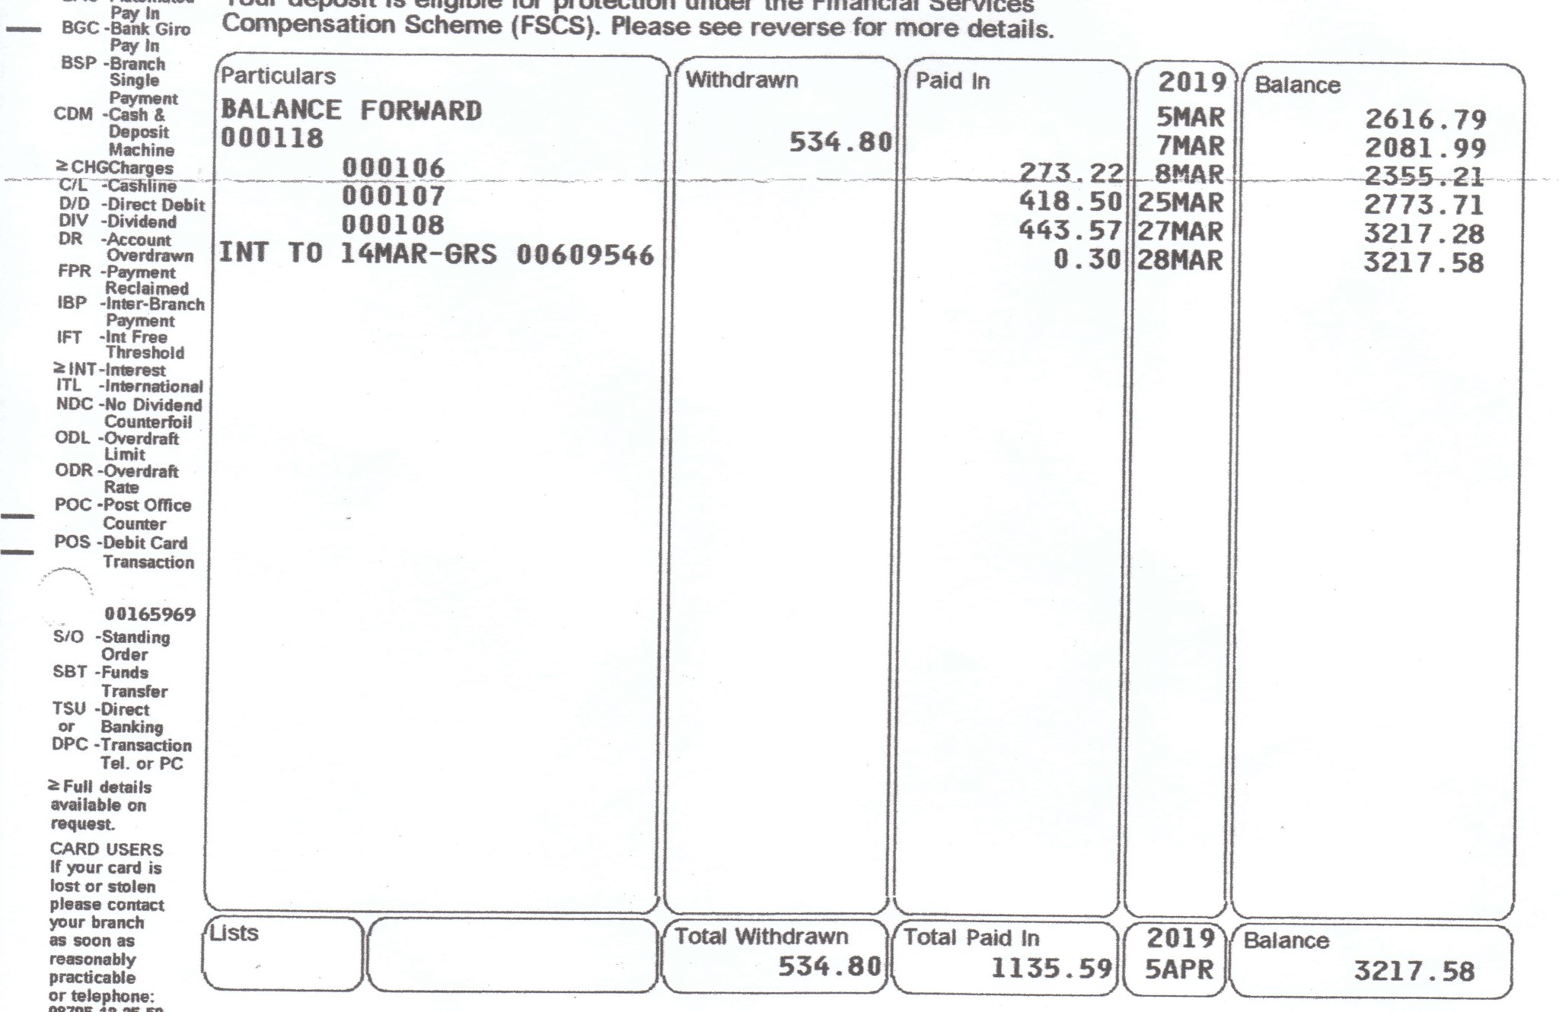

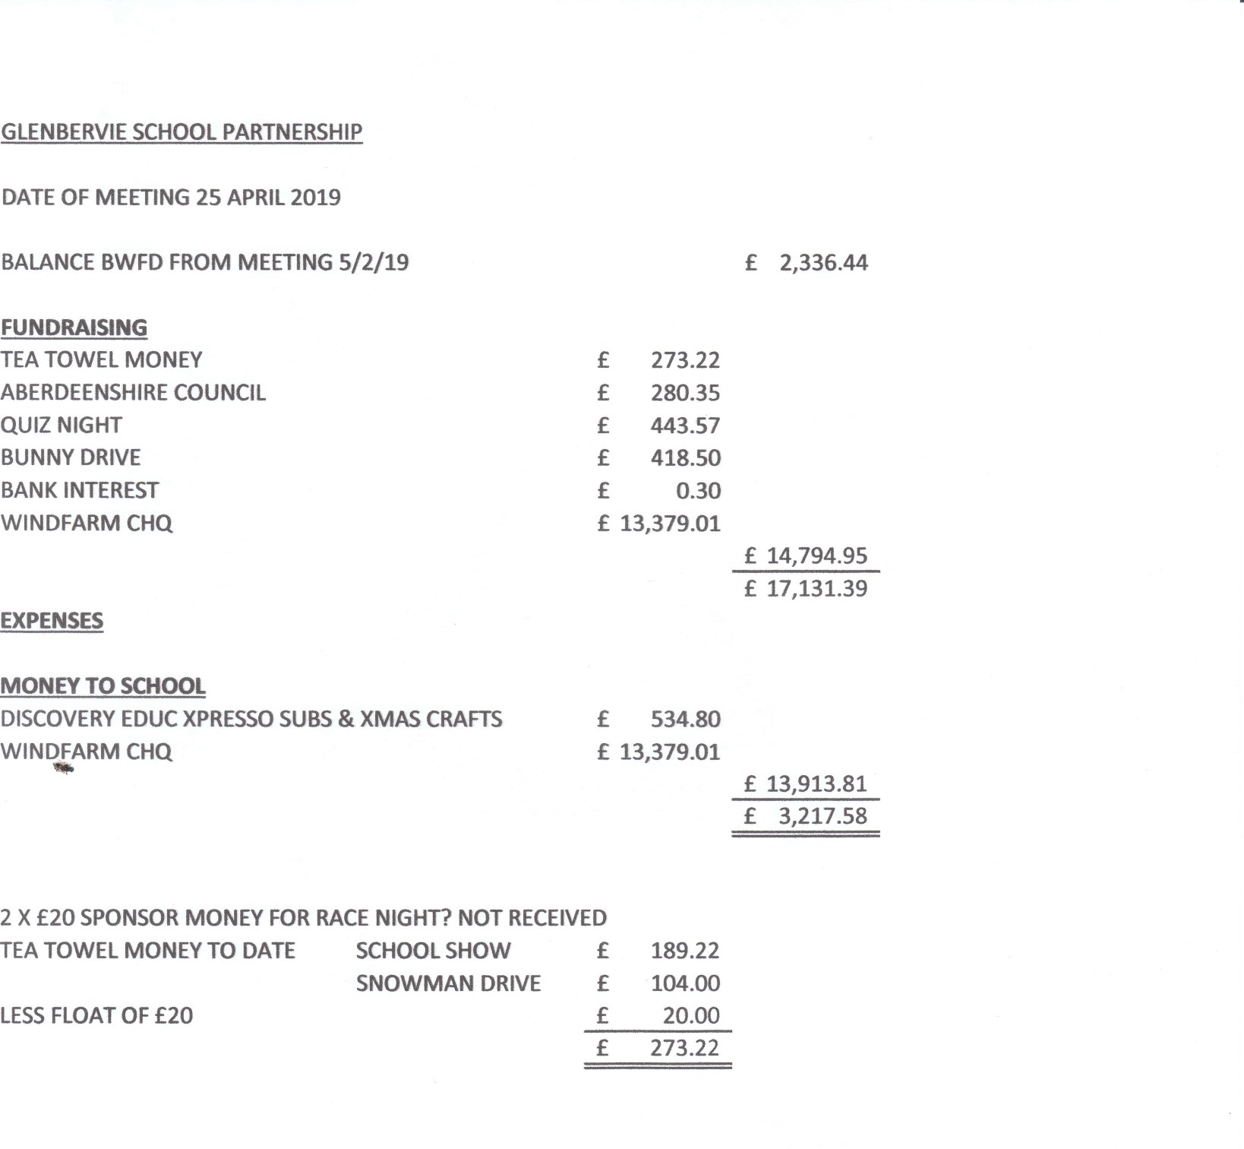
2.0 GSP Treasurers Report

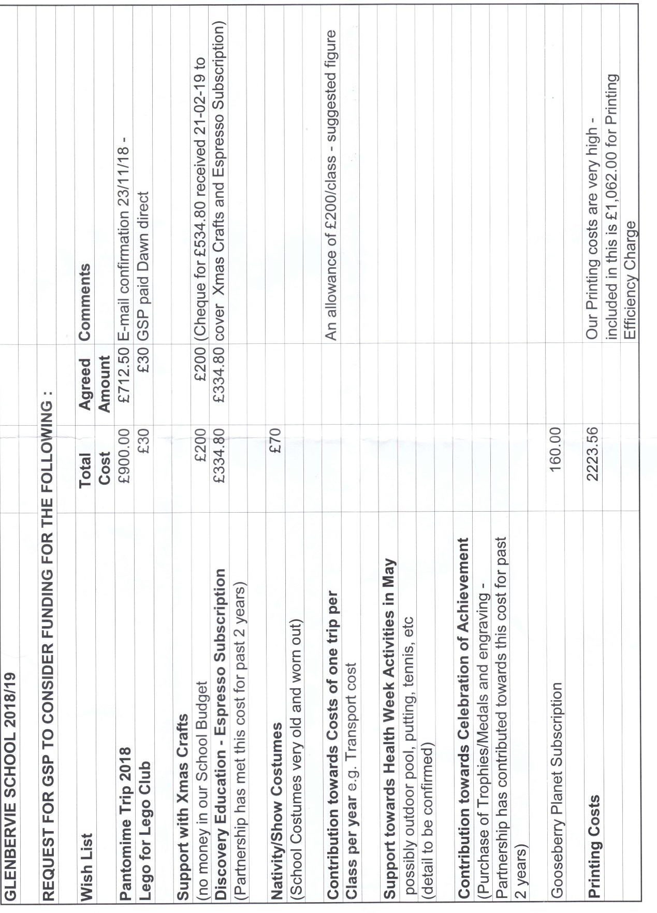
3.0 School Request For Funding List

4.0 Aberdeenshire Council Funding Position

Aggregate External Funding (AEF) as a Percentage of Scottish Average 2019/20
Per Finance Circular 2/2019 - Updated 07.03.19
AUTHORITY | Population per GAE Raw Data 2017 - used in 2019/20 Settlement | AEF 2019/20 | AEF per head as percentage of Scottish Average 2019/20 | Underfunding/ over funding | Movement from Scottish average | Band D Council Tax | CT Rank | AEF per head as percentage of Scottish Average 2019/20 Rank
 |  | £'s | % | % | £m | £
Aberdeen City | 228,800 | 342.296 | 81.03% | -18.97 | -80.14 | 1,267 | 4 | 2
Aberdeenshire | 261,800 | 429.386 | 88.83% | -11.17 | -53.98 | 1,205 | 16 | 3
Angus | 116,280 | 208.196 | 96.98% | -3.02 | -6.49 | 1,137 | 25 | 9
Argyll & Bute | 86,810 | 198.734 | 123.99% | 23.99 | 38.46 | 1,249 | 6 | 29
Clackmannanshire | 51,450 | 97.539 | 102.68% | 2.68 | 2.55 | 1,218 | 13 | 19
Dumfries & Galloway | 149,200 | 290.563 | 105.48% | 5.48 | 15.09 | 1,113 | 30 | 22
Dundee City | 148,710 | 304.414 | 110.87% | 10.87 | 29.85 | 1,278 | 3 | 24
East Ayrshire | 121,940 | 235.929 | 104.79% | 4.79 | 10.79 | 1,261 | 5 | 21
East Dunbartonshire | 108,130 | 189.727 | 95.03% | -4.97 | -9.91 | 1,211 | 15 | 7
East Lothian | 104,840 | 177.759 | 91.83% | -8.17 | -15.81 | 1,186 | 22 | 5
East Renfrewshire | 94,760 | 180.534 | 103.19% | 3.19 | 5.58 | 1,195 | 20 | 20
Edinburgh, City of | 513,210 | 747.694 | 78.91% | -21.09 | -199.85 | 1,240 | 7 | 1
Eilean Siar | 26,950 | 96.403 | 193.74% | 93.74 | 46.65 | 1,086 | 32 | 31
Falkirk | 160,130 | 288.149 | 97.46% | -2.54 | -7.50 | 1,135 | 26 | 11
Fife | 371,410 | 661.865 | 96.52% | -3.48 | -23.87 | 1,186 | 21 | 8
Glasgow City | 621,020 | 1,274.262 | 111.13% | 11.13 | 127.67 | 1,286 | 1 | 25
Highland | 235,180 | 458.108 | 105.50% | 5.50 | 23.89 | 1,234 | 9 | 23
Inverclyde | 78,760 | 168.909 | 116.16% | 16.16 | 23.49 | 1,234 | 8 | 27
Midlothian | 90,090 | 165.705 | 99.62% | -0.38 | -0.63 | 1,283 | 2 | 17
Moray | 95,780 | 163.555 | 92.49% | -7.51 | -13.28 | 1,204 | 17 | 6
North Ayrshire | 135,790 | 281.610 | 112.33% | 12.33 | 30.90 | 1,222 | 12 | 26
North Lanarkshire | 339,960 | 631.828 | 100.66% | 0.66 | 4.16 | 1,131 | 28 | 18
Orkney | 22,000 | 75.499 | 185.87% | 85.87 | 34.88 | 1,100 | 31 | 30
Perth & Kinross | 151,100 | 254.941 | 91.38% | -8.62 | -24.04 | 1,216 | 14 | 4
Renfrewshire | 176,830 | 321.535 | 98.48% | -1.52 | -4.95 | 1,200 | 18 | 13
Scottish Borders | 115,020 | 211.452 | 99.57% | -0.43 | -0.91 | 1,150 | 24 | 16
Shetland | 23,080 | 86.748 | 203.57% | 103.57 | 44.14 | 1,117 | 29 | 32
South Ayrshire | 112,680 | 205.787 | 98.92% | -1.08 | -2.25 | 1,224 | 11 | 14
South Lanarkshire | 318,170 | 575.198 | 97.92% | -2.08 | -12.24 | 1,134 | 27 | 12
Stirling | 94,000 | 172.651 | 99.48% | -0.52 | -0.90 | 1,233 | 10 | 15
West Dunbartonshire | 89,610 | 192.888 | 116.59% | 16.59 | 27.44 | 1,198 | 19 | 28
West Lothian | 181,310 | 325.958 | 97.37% | -2.63 | -8.80 | 1,162 | 23 | 10
Total Scotland | 5,424,800 | 10,015.822 | 100.00% |  |  | 1,197

