Welcome to Primary 1 at Glenbervie School. We hope you all had a lovely summer break and are ready for the excitement and challenges of Primary 1!
We thought it would be helpful to share with you now some of our routines, ways of working and what we have planned for the term ahead.

Literacy
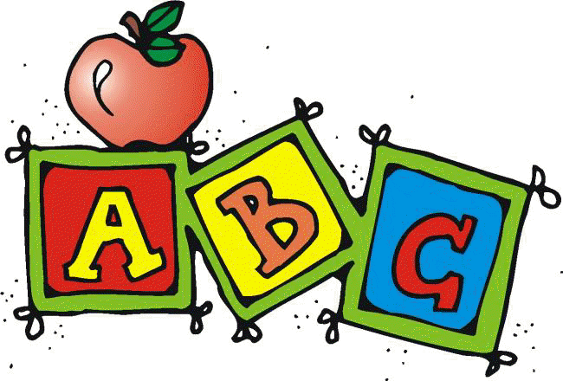
The children will soon begin our Emerging Literacy programme and will enjoy the challenges of learning new sounds and practising their formation. Each new sound will be stuck into their sound book to use and practise at home.
Reading will be being sent home at a later date with instructions and suggestions of ways to support your child.
Numeracy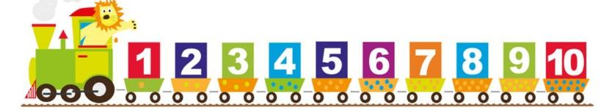
The children will be following the TeeJay scheme for maths and will begin by looking at the numbers 0-10. We will be looking at the value, formation and positioning of these numbers through a variety of activities.

Topic
Primary 1 will begin with a mini topic on ‘People who care for us at school’. We will also will be reading and looking at fairy tales and nursery rhymes.

Equipment

Gym Kits – We are timetabled for gym every Tuesday and Wednesday but it is helpful to have gym kits in school all week as our timetable can sometimes change.
Please provide an indoor gym kit (shorts and t-shirt) and an outdoor kit (joggers and a jumper) as we try to get outside when the weather allows.
Please support your child in becoming independent when dressing and undressing.
Art & Craft
To avoid uniforms getting messy it is helpful for each child to have a painting apron, this can be an old shirt or tshirt.
Water bottles – These can be brought to school on a Monday and remain in school until Friday when they will be given home to be washed.
Forest School – suitable clothing – waterproofs, trousers, t-shirt, jumper, gloves and hat.

Please ensure that all clothing/items your child brings to school is labelled with their name and your child knows how to identify his/her own belongings.

Lunch
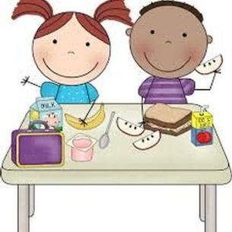
If your child is to be staying for a school lunch it would be helpful if you could discuss the menu each day to let them know the choices before they arrive in school. You will hopefully have a menu but an online version can be found at the link below. Alternatively a packed lunch can be brought to school if your child prefers.
Please also practice using cutlery at home as we only have one adult in the hall at lunchtimes.
https://www.aberdeenshire.gov.uk/media/21691/interactive-online-menu.pdf

School Pick Up
We ask that when collecting your child from school you come all the way into the playground and wait at the wall by the entrance. We are happy for you to wait in the hoosie on wet days. This will allow staff members to ensure the safety of the children. If your child is to be picked up by someone else please inform the school before the end of the day.

Homework
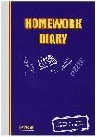
Please check your child’s homework diary on a daily basis and initial tasks once they have been completed. You can also use these diaries for any non urgent messages you wish to pass on.
The homework diary and sound book should be taken into school everyday.

We look forward to working in partnership with you and would like to emphasise that if you have any questions/queries or concerns please do not hesitate to contact us.

Regards,
Mrs G Sangster and Mrs L McConachie

