P2/3 Newsletter TERM 1 2018-19

Welcome to Primary 2/3, I hope you had a relaxing summer holiday and are feeling re-energised and ready for another exciting school year.
I am looking forward to working in partnership with you and taking the time to get to know your child with the aim of providing an exciting and engaging learning experience. I plan to maintain an open door policy so please feel free to contact me with any queries or concerns.
Literacy
After a period of revision p2/3 will continue to work through the Active Literacy Programme. This consists of learning a new sound and common words each week.
Reading will be heard several times a week. Additionally pupils will be participating in activities to encourage comprehension.
Numeracy and Mathematics
Primary 2 have begun the term by focusing on number ordering and sequencing. They will be learning to read, order, count and write numbers within 20. Primary 3 have begun by looking at the concept of multiplication. We will be focusing on counting in groups and learning our 2 times table. As a separate topic we will be looking at data handling and will learn how to collect, record and interpret information.
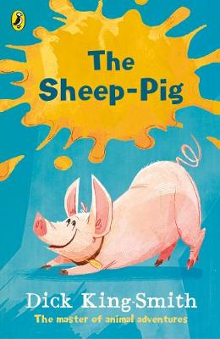
Thematic work
Our class topic this term will be ‘Farming’ The class will be learning about the different types of farming, events within the farming year and foods produced within Scotland.
As part of the topic we will also be reading ‘The Sheep Pig’ by Dick King Smith as our class novel.
If you can assist in anyway with this topic any support would be greatly appreciated.
Homework
Spelling homework will be sent home on a Monday to be returned on Friday. Reading will be given out several times a week and maths homework tasks will be issued periodically to support the learning in the classroom.
Equipment
PE Kits – We will be having PE on a Tuesday and Wednesday this term however this may change therefore I would be grateful if you could ensure that your child has their gym kit with them every day at school. PE kits will be sent home on a Friday to be washed.
Forest School
The class will have forest schools every second Wednesday. On these days we ask that your child comes to school in their forest school clothing and brings their school uniform with them to change into. However please bring in a pair of wellies to leave in school to ensure we can make the most of the outdoor environment.
Forest School dates are as follows:
- Wednesday 29th August
- Wednesday 12th September
- Wednesday 26th September
- Wednesday 10th October

Water bottles- These can be brought into school on the Monday and will be sent home at the end of the week to be washed.
I hope this information is helpful however if you have any queries or concerns please do not hesitate to contact me.

Kind Regards,
Miss L Stephen

