P4/5 Newsletter TERM 1 2015-16
Welcome Back! I hope you all had a lovely Summer break and are ready for another busy school year!
Welcome to Primary 4/5. We’re both looking forward to teaching the class this and have lots of new and exciting ideas for the year ahead. Mrs McConachie will be in class on a Monday, Tuesday and Wednesday. Mrs Glennie will therefore be in on Thursday and Friday. Should one of us be off then other one will do their best to cover the class.
We all are settling in well to our new classes and are enjoying meeting old and new friends. Please be assured we will maintain the open door policy and if you have any queries or concerns contact us by the home-school book or at the end of a school day.
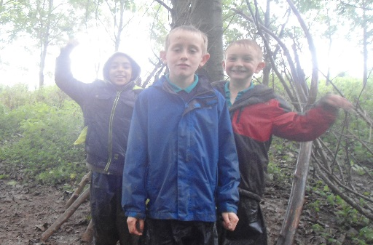
Forest School
This term Mrs McConachie will be taking the class to the Millennium Garden on a Monday afternoon to take part in Forest School Activities. These activities will cover a range of experiences – sawing, den building, team activities, art and craft and many more. For your child to enjoy the experience it is important that they come to school prepared for all weathers. We have already had one very wet and muddy afternoon there. Please provide your child with the following clothing – wellies, waterproofs (jacket + trousers), spare socks, joggers, a warm jumper and gloves (gardening gloves acceptable). The school do have waterproofs which your child is welcome to borrow.
Please also see the table below for important information about the weekly routine. Reading will be heard once a week and then reading will be sent home for the following week. We would appreciate it you could sign the book to indicate that you have completed the task with your child.

Some final requests that would ensure Primary 4/5 runs smoothly are; Please name all items coming into school, especially uniform, as already we have had missing jumpers and jackets! Please bring in a rainy day activity to avoid boredom on those rainy days and finally remember to write names on lunch tickets to avoid any confusion in the dinner hall.

Day | Important information
Mon  Mrs McConachie | Homework – Spelling – Hand out  - Maths - Hand in  Forest School – waterproofs, wellies, hat, gloves, spare socks,  joggers, jumper, gloves,
Tue  Mrs McConachie | PE – Miss Munro – white t-shirt, blue shorts, gym shoes
Wed  Mrs McConachie | Homework – Maths – Hand out
Thurs  Mrs Glennie | PE- Mrs Glennie
Fri  Mrs Glennie | Homework - Spelling – Hand in  Friday Activities

We hope this is useful to you and feel free to contact us through the Home School Notebook with any further queries.
Best Wishes,
Mrs L McConachie and Mrs J Glennie

