****Glenbervie Primary School



Curriculum Rationale

Every pupil has a right to an Education- (Article 28 UNCRC)

At Glenbervie we strive to be a fully inclusive learning community aiming for the highest standards of achievement in work, life and play.

At Glenbervie Primary we recognise our unique location at the heart of the Mearns. Glenbervie School is a small, rural school situated in the village of Drumlithie, which is a mile west of the A90, seven miles south of Stonehaven, Drumlithie is a friendly village with a new shop, hotel, small church, bowling club and well used village hall. It is a community that works in partnership with the school to enhance the learning and experiences of our pupils. Close links with our local farming communities and businesses such as East Coast Viners and Macphies allow improved learning provision and have positive impacts for the young people and families in our community. As a result of effective partnerships our learners have access to extended learning pathways through which they are developing skills for learning, work and life.

[](https://www.google.co.uk/url?sa=i&rct=j&q=&esrc=s&frm=1&source=images&cd=&cad=rja&uact=8&ved=0ahUKEwinoMqO84jMAhXMfxoKHd06B5cQjRwIAw&url=https://1stdirectory.co.uk/companies/east-coast-viners-grain/&psig=AFQjCNG6-qajr9VhTPwBoiBYdtVKy-1lkw&ust=1460543620292525)

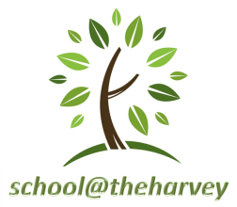The school is surrounded by a playground and has the added advantage of a large playing field within a close proximity. This playing field is used by the children during fine weather. An outdoor classroom area, the MOLE (Multipurpose Outdoor Learning Environment) Zone, provides a stimulating setting for learning. Pupils use a local woodland area on a regular basis for outdoor learning activities and gardening (school@theharvey).

At Glenbervie we aim to give the children an atmosphere where they can feel secure and happy. It is our main aim to make the children’s, parent’s and staff’s time at Glenbervie School a happy and profitable one.

We take pride in the fact that this is a happy and industrious school with a real sense of team spirit. The education of a child is far too important to be left to a school alone. Parents have a very important part to play too. We pride ourselves on our Open Door Policy and increased parental engagement in the children’s learning. The partnership, help and support from parents is strengthening leadership at all levels within our school.

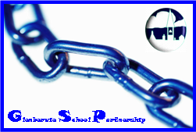

**Our school motto….**

'Amor Proximi'

Love Each Other



**school motto….**

**Our Shared Values**

At Glenbervie School we value Responsibility, Fairness, Respect,

Honesty and Care.

**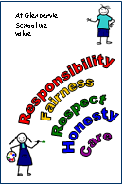**

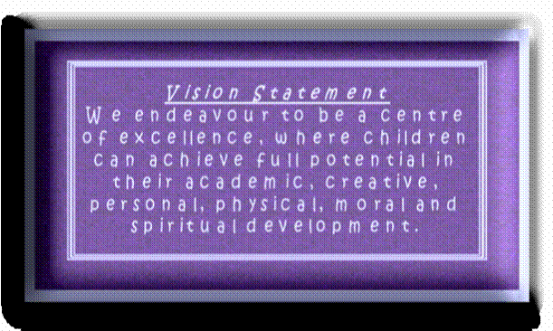

**Vision Statement**We endeavour to be a centre of excellence. Where children can achieve full potential in their academic, creative, personal, physical, moral and spiritual development.

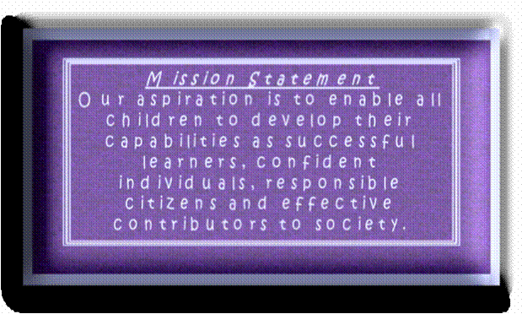

**Mission Statement**  
Our aspiration is to enable all children to develop their capabilities as successful learners, confident individuals, responsible citizens and effective contributors to society.

**School Aims**

In pursuit of the above we have the following School Aims that are designed to make clear to the children how they can achieve and are embedded within the United Nations Charter of the Rights of the Child (U.N.C.R.C.) as we are a Rights Respecting School. Articles 28 & 29

|  |  |  |
| --- | --- | --- |
| ***School Aims*** | ***We’re aiming for…*** |  |
| 1. To engage young people in the highest quality learning activities | *High Quality Learning* |  |
| 2. To focus on outcomes and maximise success for all learners | *Success for All* | j0149125 |
| 3. To develop a common vision across young people, parents and staff | *A Common Vision* | BD19083_ |
| 4. To foster high quality leadership at all levels | *High Quality Leadership* | j0400090 |
| 5. To work in partnership with other agencies and our community. | *Partnership with Community and Others* |  |
| 6. To work with parents to improve learning | *Partnership with Parents* | j0386654 |
| 7. To reflect on our work and thrive on challenge | *Enjoyable Challenges* |  |
| 8. To value and empower our staff and young people | *Everyone Feeling Valued* | j0428525 |
| 9. To promote well-being and respect | *A Caring Environment* | j0402208 |
| 10. To develop a culture of ambition and achievement | *An Ethos of Achievement* | j0313722 |

**Our Curriculum**



Our aim is that our curriculum equips young people with high levels of literacy, numeracy and thinking skills and supports the development of their health and wellbeing.

We intend it to enable every child to develop his or her full potential through a broad range of challenging, well-planned experiences which help them develop qualities of citizenship, enterprise and creativity.

We also aim to offer rich opportunities for development, progression and achievement for children who need additional support for their learning, using individualised educational programmes, co-ordinated support plans and any other plans to support them.

At Glenbervie School we recognise that the curriculum is more than curriculum areas and subjects; it is the totality of experiences which are planned for children and young people through their education – a canvas upon which their learning experiences are formed.

At all stages the curriculum will include learning through:

* the ethos and life of the school as a community
* curriculum areas and subjects
* interdisciplinary projects and studies
* opportunities for personal achievement

The Curriculum for Excellence core values encompass the development of four key attributes;

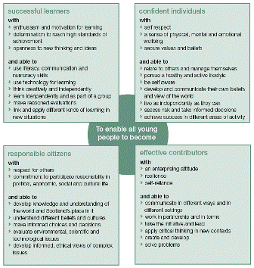

The four contexts in which we will base our curricular developments on are as follows:

1. **The Ethos and Life of the school as a community**

We base our ethos on the work of the UNCRC Articles and embed a Rights Respecting School approach through all areas in the school. Teachers and staff know that positive relationships and the climate for learning in a school –its values, its ethos and its life as a community – are essential starting points for successful learning. The wider life of the school – activities such as assemblies, community events and school projects – make an important contribution to the development of the four capacities, helping to enable all young people to become successful learners, confident individuals, responsible citizens and effective contributors. We encourage pupils to take responsibility within the school.  This allows them to have a say in aspects of what happens in school and allows them to see that they can make a difference.  Some of the ways that we do this are: buddying, membership of pupil parliament and sub-committees, undertaking responsibilities and playing a part in decision making.

An ethos of open, positive, supportive relationships promote a climate where pupils feel safe and secure.  Good behaviour and positive attitudes are fostered through praise and recognition.  Pupils are encouraged to value themselves and others and develop effective citizenship skills.  These skills are fostered through co-operative learning activities.

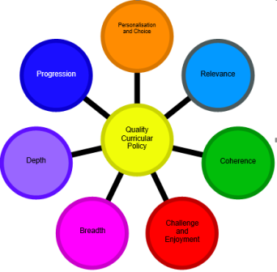

1. **Curriculum areas and subjects**

Curriculum areas and subjects provide familiar and important vehicles for learning. We recognise their key role within the curriculum. We are constantly reviewing curriculum areas and subjects, ensuring we take full account of the contributions they can make to developing the four capacities and preparing learners for the challenges of the future. Curriculum for Excellence identifies seven **principles** for curriculum design that are considered and used to evaluate the effectiveness of our planned learner experiences, programmes and resources.

Topics for each area of the curriculum have been organised into a programme of study, using two and three year cycles, for early, middle and upper stages. We collaboratively worked with our Cluster schools to bundle our outcomes into 3 year cycles and we try, to follow this to allow a consistency of coverage across our cluster.

1. **Interdisciplinary projects and studies**

We acknowledge that the curriculum needs to include space for learning beyond subject boundaries, so that learners can make connections between different areas of learning. Through interdisciplinary activities of this kind, young people can develop their organizational skills, creativity, teamwork and the ability to apply their learning in new and challenging contexts. To be successful, these activities need to be well planned with a clear purpose and outcomes in mind. We are continuing to develop interdisciplinary projects at all stages. At Glenbervie we take advantage of those naturally occurring ‘big questions’ which children will often ask to engage in Interdisciplinary learning. Interdisciplinary Learning adds **depth** and **challenge** **and enjoyment** to children’s learning [](http://www.google.co.uk/url?sa=i&rct=j&q=&esrc=s&frm=1&source=images&cd=&cad=rja&uact=8&ved=0ahUKEwicy7G19ojMAhUBlxoKHeQ7Cg8QjRwIBw&url=http://nicolaslevy.net/links_references/0_img/&psig=AFQjCNGv1J1EBMXg1kgYuAuTfjZvCMDZMw&ust=1460544499313345)

[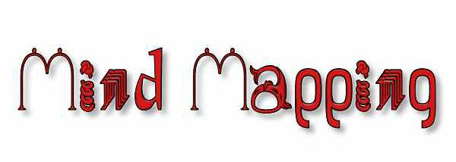](http://www.google.co.uk/url?sa=i&rct=j&q=&esrc=s&frm=1&source=images&cd=&cad=rja&uact=8&ved=0ahUKEwjMloWX9ojMAhVIQBoKHfFMBQUQjRwIBw&url=http://events.r20.constantcontact.com/register/event?oeidk%3Da07e8mdtfo9af267864&psig=AFQjCNFOH2x5H00OSQEoIK0Bn1PpBpXeLQ&ust=1460544332492767) [](http://www.google.co.uk/url?sa=i&rct=j&q=&esrc=s&frm=1&source=images&cd=&cad=rja&uact=8&ved=0ahUKEwiEoPCD9ojMAhXCSRoKHYnLAUAQjRwIBw&url=http%3A%2F%2Femmrc.org%2Fhamlet-character-map-2009&psig=AFQjCNFOH2x5H00OSQEoIK0Bn1PpBpXeLQ&ust=1460544332492767)

[](http://www.google.co.uk/url?sa=i&rct=j&q=&esrc=s&frm=1&source=images&cd=&cad=rja&uact=8&ved=0ahUKEwiEoPCD9ojMAhXCSRoKHYnLAUAQjRwIBw&url=http://emmrc.org/hamlet-character-map-2009&psig=AFQjCNFOH2x5H00OSQEoIK0Bn1PpBpXeLQ&ust=1460544332492767)

[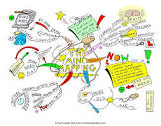](https://www.google.co.uk/url?sa=i&rct=j&q=&esrc=s&frm=1&source=images&cd=&cad=rja&uact=8&ved=0ahUKEwi_556x9YjMAhUDBBoKHR_aCXMQjRwIAw&url=https://kirahfineart.wordpress.com/tag/mind-mapping/&psig=AFQjCNFwFbhopvL3Moa1wOpLnpGdRJ7cQg&ust=1460544229853000)

[](https://www.google.co.uk/url?sa=i&rct=j&q=&esrc=s&frm=1&source=images&cd=&cad=rja&uact=8&ved=0ahUKEwi_556x9YjMAhUDBBoKHR_aCXMQjRwIAw&url=https://kirahfineart.wordpress.com/tag/mind-mapping/&psig=AFQjCNFwFbhopvL3Moa1wOpLnpGdRJ7cQg&ust=1460544229853000)

[](http://www.google.co.uk/url?sa=i&rct=j&q=&esrc=s&frm=1&source=images&cd=&cad=rja&uact=8&ved=0ahUKEwicy7G19ojMAhUBlxoKHeQ7Cg8QjRwIBw&url=http://nicolaslevy.net/links_references/0_img/&psig=AFQjCNGv1J1EBMXg1kgYuAuTfjZvCMDZMw&ust=1460544499313345)

by allowing them to apply the skills and knowledge they have learned in a child led and stimulating context. IDL, which is planned with the children, takes account of children’s needs and interests adding **personalisation and choice** to our curriculum.

1. **Opportunities for personal achievement**

Opportunities for personal achievement, planned through the school, enrich the life experience of learners. Taking part in activities such as performances, community or enterprise activities and trips plays an important part in widening our pupils’ horizons and developing confidence. We also respond to the personal interests and aptitudes of learners through clubs, community, charitable and fund-raising activities. Some of these activities are voluntary for learners and are organised as ‘extra-curricular’ opportunities. However, they play a major part in creating opportunities for individual growth, progress and achievement. We have therefore developed ways of making these experiences available for all learners, including our Lifeskills Award Scheme. Recognition of rewards is made publicly, during assembly for personal achievements and successes. At assembly we will have the opportunity to share our Praise slips and Shared Values awards. Similarly in class, all pupils on a weekly basis have a chance to share their “Good News” with the class and have this information displayed in class or on the noticeboard. This highlights to the children that we value the contributions that they make both in and out of school and that we recognise them as individuals with different skills, talents and interests. Our house competition allows us to recognise many achievements. Achievements are shared with our parents through our Snapshots, Learning Profiles, Home-school diaries and of course Termly Newsletters and website updates.





**Learning and Teaching**

[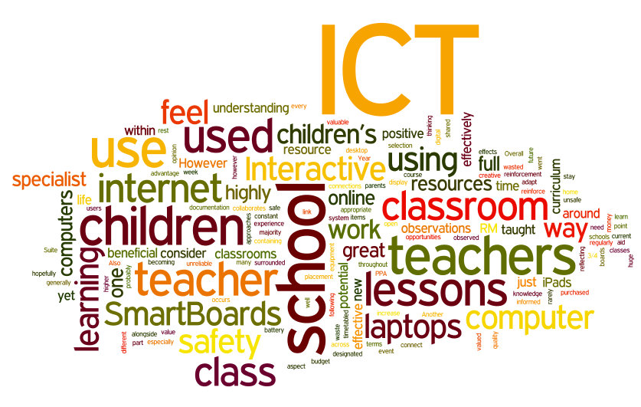](http://www.google.co.uk/url?sa=i&rct=j&q=&esrc=s&frm=1&source=images&cd=&cad=rja&uact=8&ved=0ahUKEwjZl7DC-IjMAhUG2RoKHZ22AvEQjRwIBw&url=http://www.bayprimary.org/?page_id%3D87&psig=AFQjCNGJqWgU4Tdlvrxua8VsM1PaXtX6lg&ust=1460545065711840)

The success of our curriculum is through the delivery of high-quality learning and teaching.  This is at the heart of our work and the use of a variety of teaching methodologies is an essential feature of our curriculum.  A wide range of **teaching strategies** are implemented by all staff, where approaches to learning and assessment are varied and pupil-centred. To this end we adopt a variety of pedagogical approaches to ensure our curriculum is interesting, engaging and child centred. For instance children are involved in individual tasks, group tasks, practical tasks, games based activities or activities which make use of ICT. We also engage in outdoor learning, educational visits where appropriate and take opportunities to have visiting speakers in our school to further excite and enthuse our learners. All children are expected to achieve their very best, set high yet realistic targets for themselves and they are supported to work at a level that challenges them. At Glenbervie School we aim to create a powerful learning environment. We are aware of the importance of physical factors on learning and aspire to be motivational teachers who influence the self-motivation of all pupils by using the identified approaches. We aim to cultivate an environment in which a perceived failure is turned into a positive learning experience. We proactively plan opportunities through Health & Wellbeing lessons for children to explore and reflect upon their attitudes and values.

[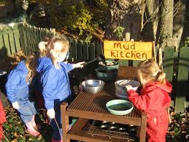](https://www.google.co.uk/imgres?imgurl=https://www.dhsfg.org.uk/_images/foundation-stage/foundation-outdoor-learning-01-lrg.jpg&imgrefurl=https://www.dhsfg.org.uk/foundation-stage/outdoor-learning&docid=5yJnbvgTpVLcDM&tbnid=BaD00dbKfdBbaM:&w=800&h=600&safe=strict&ved=0ahUKEwjL68v1-IjMAhVM5xoKHWA3DqoQMwhCKBswGw&iact=mrc&uact=8)

**Assessment**

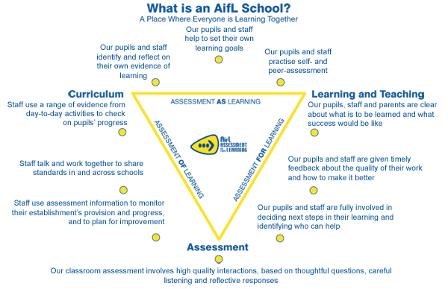We use a range of assessment approaches both summative and formative to monitor our progress across the curriculum. Formative assessment is ongoing and informal and assesses those small steps which children take in their learning every day. Sources of formative assessment evidence may include observations of children carrying out a practical task, a piece of written work or a photo showing learning taking place. Assessment for Learning Strategies are promoted and we encourage children to self or peer assess their work as a way of having children engage in reflective discussions. These discussions enable pupils to reflect on whether the intended learning has been achieved, what their strengths are and how these can be improved. The pupils often discuss their next steps.

Summative assessment is a more formal approach which may be used to at the end of a block of work or for diagnostic purposes. The data is analysed termly by staff with high quality Professional dialogues and a robust tracking system is used to ensure effective use of resources, support and raise attainment within the school.

Continued Professional Development (CPD) processes and collegiate working support staff in the field of learning and teaching.  Colleagues share practice, within both the school and the Cluster, which has led to further reflection of practice, incorporating new ways of engaging and supporting our learners.  Our collegiate approach to school improvement and moderation results in high standards of consistency and is key to raising attainment levels.

[](http://www.google.co.uk/url?sa=i&rct=j&q=&esrc=s&frm=1&source=images&cd=&cad=rja&uact=8&ved=0ahUKEwiiwbrC_YjMAhWKlxoKHX45DEwQjRwIBw&url=http://www.mearnspreschoolplaygroup.btck.co.uk/About%20us/History&psig=AFQjCNHfa6uJ2gKhmR5mMN2Dch2-RyEgow&ust=1460546385677777)

**Transitions**

Our collaborative working at Glenbervie means that transitions within **all** stages are carefully planned and monitored. Continuous tracking and Professional dialogue ensures the staff work together to ensure both curricular and pastoral support. Continuity and progression is at the centre of our children’s learning.

On entry to Primary One the team at Glenbervie ensure a pro-longed induction process where both children and parents are invited to induction events. In tandem we also work with our many Early Years settings to provide some partnership working to allow joint delivery of the Early Years Curriculum. This allows, even at this early stage some consistency in assessment approaches and expectations. Our programme offers staff, children and parents the opportunity to collaborate so that mental, emotional, social and physical needs are met within our setting.

Similarly, as our pupils move on from Glenbervie, most transfer to Mackie Academy for S1. An existing well established, yet dynamic programme called “Aiming For High” exists allowing pupils from all our cluster schools to join their peers to prepare for transition. The programme offers both pastoral and curriculum support to learners, whilst allows staff the opportunity to engage with colleagues to ensure continuity and progression is made.

[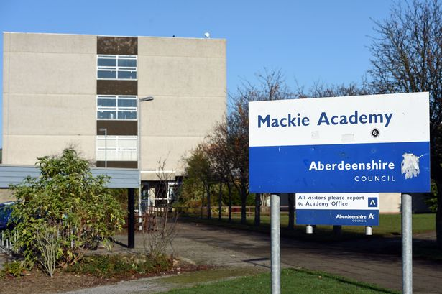](http://www.google.co.uk/url?sa=i&rct=j&q=&esrc=s&frm=1&source=images&cd=&cad=rja&uact=8&ved=0ahUKEwih1bnd_YjMAhVJtRoKHUOlDlkQjRwIBw&url=http://www.dailyrecord.co.uk/news/scottish-news/teenager-charged-police-expelled-school-6764325&psig=AFQjCNEEsS9KVb5R1de42BJhEatLEl1UHg&ust=1460546455032027)

**Next Steps**

Being committed to this shared vision, value and aims is essential, but it is important that we strive to keep it relevant to our unique school and community. Collaborative leadership will help us move forward with this and keep us continually improving. We will continue to engage in both national and local initiatives to initiate well informed changes that promotes equity, creativity and self-evaluation that brings continuous improvement for our pupils, staff and partners. We will then continue to ensure we have effective strategies in place to monitor and evaluate the impact of these changes on outcomes for learners and the work of Glenbervie School.

