P2/3/4 Newsletter TERM 1 2017-18

Welcome to primary 2/3/4! We hope you had a fantastic summer holiday and are looking forward to another exciting and busy year at Glenbervie School.
We are looking forward to taking the time to get to know your child and develop a positive relationship with the aim to provide exciting and engaging learning experiences.
Miss Stephen will be in class on Monday, Tuesday, Thursday and Friday and Mrs Ingram will be in class on a Wednesday. We will maintain an open door policy and if you have any queries or concerns please contact us by the home-school book or at the end of a school day.
Literacy
After a period of revision p2/3/4 will continue to work through the Active Literacy Programme, learning a new sound each week.
Reading will be heard several times a week. Additionally pupils will be participating in activities to encourage comprehension.
As well as individual reading, pupils will be engaging in a class novel study of ‘The Owl Who’s Afraid of the Dark’.
Numeracy and Mathematics
Primary 2/3/4 have begun the term with some revision of number sequences. Continuing on from this the class will be using a mixture of Teejay and Scottish Heinemann Maths to extend their learning.

Thematic work
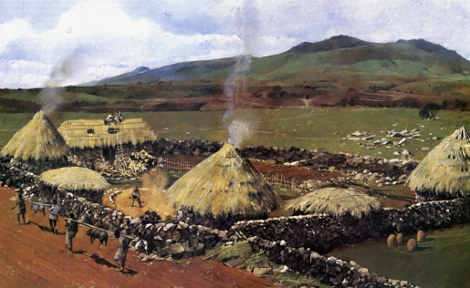
Our class topic this term will be ‘The Invaders!’ The class will be learning about life in ancient Britain with a particular focus on the Celts and the Vikings. We plan to explore how the Celts and Vikings lived and compare life in ancient Britain to our own.
Homework
Spelling homework will be sent home on a Tuesday to be returned on Friday. However additional spelling tasks may be given out during the first few weeks of revision so please check your child’s homework diary for updates.
Reading will be given out several times a week and maths homework tasks will be issued periodically to support the learning in the classroom.
Equipment
PE Kits – We will be having PE on a Monday and a Tuesday however we would be grateful if you could ensure that your child has their gym kit with them every day at school. Please check that all items of clothing are named.
Additionally it would be appreciated if a pair of wellies could be left in school. This will allow us to make the most of the outdoor environment.
Water bottles- These can be brought into school on the Monday and will be sent home at the end of the week to be washed.

We hope this information is helpful however if you have any queries please feel free to contact us.

Kind Regards,
Miss L Stephen and Mrs F Ingram

