Glenbervie School Term 2 Physical Education
Traditional & Creative Scottish Country Dance

In term 2 we have been learning about Scottish Country Dancing and focusing on developing a number of different dances.
Some examples of what we have been learning can be seen below –
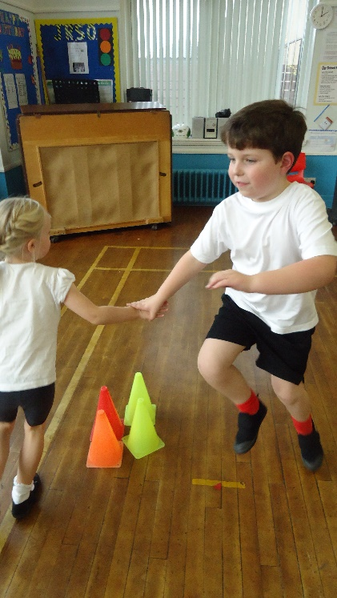
We have been learning how to do the Grand Old Duke of York dance.
We had to work together with our partner and with others in the class to keep to the time of the music and each other.
We also had to remember each part of the dance and link them together.

We have also been learning how to skip, gallop, side step, doh-si-doh and work with each other.
We have also had to work individually or co-operatively with a partner or in a group.
One dance we learned was called “The Loch Ness Monster”

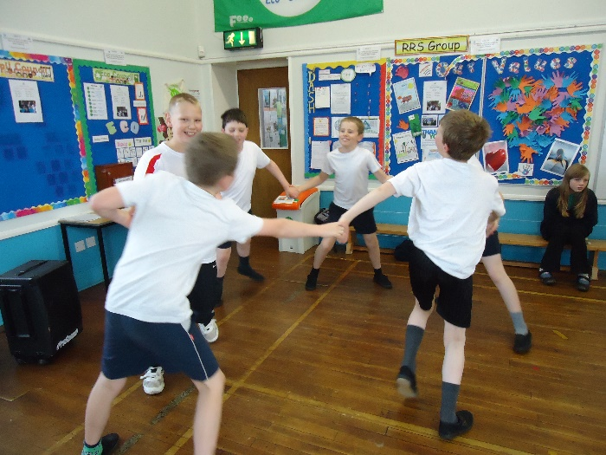

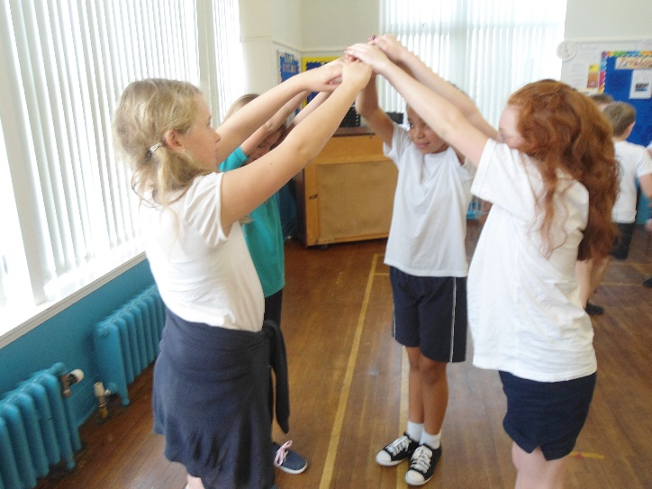
We can move in time to the music using different travelling steps.
We understand how dancing can make me feel good.
We have made lots of different shapes with our dance and can change from one shape to the other.

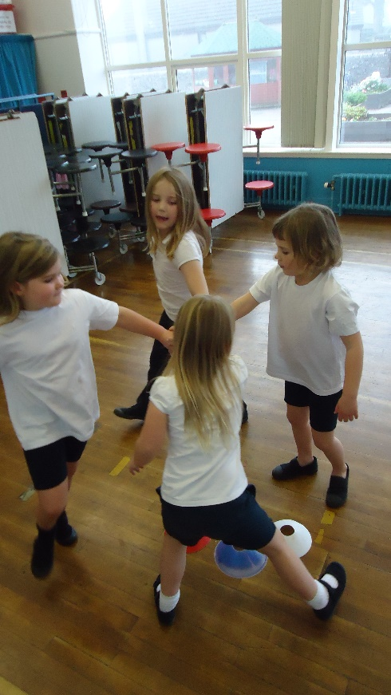
We can create our own Scottish Country Dance in a small group.
We have had to use the number “8” to make up each part of the dance.
We have had to listen and share our ideas to make up the dance and ensure everyone works together

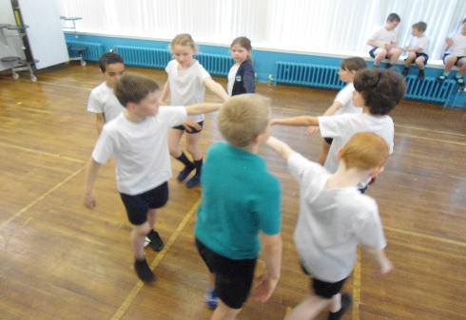
We have had to move to the beat of the music with our group and with each other by following simple instructions to learn each part of the dance.

